






Prepare vegetables, eggs and farinaceous dishes
D1.HCC.CL2.18
Trainer Guide

Prepare vegetables, eggs and farinaceous dishes

D1.HCC.CL2.18

Trainer Guide




Project Base
William Angliss Institute of TAFE
555 La Trobe Street
Melbourne 3000 Victoria
Telephone: | (03) 9606 2111
Facsimile: | (03) 9670 1330
Acknowledgements
Project Director: | Wayne Crosbie
Chief Writer: | Alan Hickman
Subject Writer: | Garry Blackburn
Project Manager: | Alan Maguire
Editor: | Jim Irwin
DTP/Production: | Daniel Chee, Mai Vu, Kaly Quach
The Association of Southeast Asian Nations (ASEAN) was established on 8 August 1967. The Member States of the Association are Brunei Darussalam, Cambodia, Indonesia, Lao PDR, Malaysia, Myanmar, Philippines, Singapore, Thailand and Viet Nam.
The ASEAN Secretariat is based in Jakarta, Indonesia.
General Information on ASEAN appears online at the ASEAN Website: www.asean.org.
All text is produced by William Angliss Institute of TAFE for the ASEAN Project on “Toolbox Development for Front Office, Food and Beverage Services and Food Production Divisions”.
This publication is supported by the Australian Government’s aid program through the ASEAN-Australia Development Cooperation Program Phase II (AADCP II).
Copyright: Association of Southeast Asian Nations (ASEAN) 2013.
All rights reserved.
Disclaimer
Every effort has been made to ensure that this publication is free from errors or omissions. However, you should conduct your own enquiries and seek professional advice before relying on any fact, statement or matter contained in this book. The ASEAN Secretariat and William Angliss Institute of TAFE are not responsible for any injury, loss or damage as a result of material included or omitted from this course. Information in this module is current at the time of publication. Time of publication is indicated in the date stamp at the bottom of each page.
Some images appearing in this resource have been purchased from stock photography suppliers Shutterstock and iStockphoto and other third party copyright owners and as such are non-transferable and non-exclusive. Clip arts, font images and illustrations used are from the Microsoft Office Clip Art and Media Library. Some images have been provided by and are the property of William Angliss Institute.
Additional images have been sourced from Flickr and SKC and are used under Creative Commons licence: http://creativecommons.org/licenses/by/2.0/deed.en
File name: TG_Prepare_veg_eggs_&_farinaceous_dishes_FN_240114





Table of contents
Competency Based Training (CBT) and assessment – An introduction for trainers 1
Competency standard 11
Notes and PowerPoint slides 19
Cookery practical classes: Recommended training equipment 49
Instructions for Trainers for using PowerPoint – Presenter View 51
Appendix – ASEAN acronyms 53

Competency Based Training (CBT) and assessment – An introduction for trainers

Competency
Competency refers to the ability to perform particular tasks and duties to the standard of performance expected in the workplace.
Competency requires the application of specified knowledge, skills and attitudes relevant to effective participation, consistently over time and in the workplace environment.
The essential skills and knowledge are either identified separately or combined.
Knowledge identifies what a person needs to know to perform the work in an informed and effective manner.
Skills describe the application of knowledge to situations where understanding is converted into a workplace outcome.
Attitude describes the founding reasons behind the need for certain knowledge or why skills are performed in a specified manner.
Competency covers all aspects of workplace performance and involves:
- Performing individual tasks
- Managing a range of different tasks
- Responding to contingencies or breakdowns
- Dealing with the responsibilities of the workplace
- Working with others.

Unit of Competency
Like with any training qualification or program, a range of subject topics are identified that focus on the ability in a certain work area, responsibility or function.
Each manual focuses on a specific unit of competency that applies in the hospitality workplace.
In this manual a unit of competency is identified as a ‘unit’.
Each unit of competency identifies a discrete workplace requirement and includes:
- Knowledge and skills that underpin competency
- Language, literacy and numeracy
- Occupational health and safety requirements.
Each unit of competency must be adhered to in training and assessment to ensure consistency of outcomes.

Element of Competency
An element of competency describes the essential outcomes within a unit of competency.
The elements of competency are the basic building blocks of the unit of competency. They describe in terms of outcomes the significant functions and tasks that make up the competency.
In this manual elements of competency are identified as an ‘element’.

Performance criteria
Performance criteria indicate the standard of performance that is required to demonstrate achievement within an element of competency. The standards reflect identified industry skill needs.
Performance criteria will be made up of certain specified skills, knowledge and attitudes.

Learning
For the purpose of this manual learning incorporates two key activities:
- Training
- Assessment.
Both of these activities will be discussed in detail in this introduction.
Today training and assessment can be delivered in a variety of ways. It may be provided to participants:
- On-the-job – in the workplace
- Off-the-job – at an educational institution or dedicated training environment
- As a combination of these two options.
No longer is it necessary for learners to be absent from the workplace for long periods of time in order to obtain recognised and accredited qualifications.

Learning Approaches
This manual will identify two avenues to facilitate learning:
Competency Based Training (CBT)
This is the strategy of developing a participant’s competency.
Educational institutions utilise a range of training strategies to ensure that participants are able to gain the knowledge and skills required for successful:
- Completion of the training program or qualification
- Implementation in the workplace.
The strategies selected should be chosen based on suitability and the learning styles of participants.

Competency Based Assessment (CBA)
This is the strategy of assessing competency of a participant.
Educational institutions utilise a range of assessment strategies to ensure that participants are assessed in a manner that demonstrates validity, fairness, reliability, flexibility and fairness of assessment processes.

Flexibility in Learning
It is important to note that flexibility in training and assessment strategies is required to meet the needs of participants who may have learning difficulties. The strategies used will vary, taking into account the needs of individual participants with learning difficulties. However they will be applied in a manner which does not discriminate against the participant or the participant body as a whole.
Catering for Participant Diversity
Participants have diverse backgrounds, needs and interests. When planning training and assessment activities to cater for individual differences, trainers and assessors should:
- Consider individuals’ experiences, learning styles and interests
- Develop questions and activities that are aimed at different levels of ability
- Modify the expectations for some participants
- Provide opportunities for a variety of forms of participation, such as individual, pair and small group activities
- Assess participants based on individual progress and outcomes.
The diversity among participants also provides a good reason for building up a learning community in which participants support each other’s learning.
Participant Centred Learning
This involves taking into account structuring training and assessment that:
- Builds on strengths – Training environments need to demonstrate the many positive features of local participants (such as the attribution of academic success to effort, and the social nature of achievement motivation) and of their trainers (such as a strong emphasis on subject disciplines and moral responsibility). These strengths and uniqueness of local participants and trainers should be acknowledged and treasured
- Acknowledges prior knowledge and experience – The learning activities should be planned with participants’ prior knowledge and experience in mind
- Understands learning objectives – Each learning activity should have clear learning objectives and participants should be informed of them at the outset. Trainers should also be clear about the purpose of assignments and explain their significance to participants
- Teaches for understanding – The pedagogies chosen should aim at enabling participants to act and think flexibly with what they know
- Teaches for independent learning – Generic skills and reflection should be nurtured through learning activities in appropriate contexts of the curriculum. Participants should be encouraged to take responsibility for their own learning
- Enhances motivation – Learning is most effective when participants are motivated. Various strategies should be used to arouse the interest of participants
- Makes effective use of resources – A variety of teaching resources can be employed as tools for learning
- Maximises engagement – In conducting learning activities, it is important for the minds of participants to be actively engaged
- Aligns assessment with learning and teaching – Feedback and assessment should be an integral part of learning and teaching
- Caters for learner diversity – Trainers should be aware that participants have different characteristics and strengths and try to nurture these rather than impose a standard set of expectations.
Active Learning
The goal of nurturing independent learning in participants does not imply that they always have to work in isolation or solely in a classroom. On the contrary, the construction of knowledge in tourism and hospitality studies can often best be carried out in collaboration with others in the field. Sharing experiences, insights and views on issues of common concern, and working together to collect information through conducting investigative studies in the field (active learning) can contribute a lot to their eventual success.
Active learning has an important part to play in fostering a sense of community in the class. First, to operate successfully, a learning community requires an ethos of acceptance and a sense of trust among participants, and between them and their trainers. Trainers can help to foster acceptance and trust through encouragement and personal example, and by allowing participants to take risks as they explore and articulate their views, however immature these may appear to be. Participants also come to realise that their classmates (and their trainers) are partners in learning and solving.
Trainers can also encourage cooperative learning by designing appropriate group learning tasks, which include, for example, collecting background information, conducting small-scale surveys, or producing media presentations on certain issues and themes. Participants need to be reminded that, while they should work towards successful completion of the field tasks, developing positive peer relationships in the process is an important objective of all group work.

Competency Based Training (CBT)
Principle of Competency Based Training
Competency based training is aimed at developing the knowledge, skills and attitudes of participants, through a variety of training tools.
Training Strategies
The aims of this curriculum are to enable participants to:
- Undertake a variety of subject courses that are relevant to industry in the current environment
- Learn current industry skills, information and trends relevant to industry
- Learn through a range of practical and theoretical approaches
- Be able to identify, explore and solve issues in a productive manner
- Be able to become confident, equipped and flexible managers of the future
- Be ‘job ready’ and a valuable employee in the industry upon graduation of any qualification level.
To ensure participants are able to gain the knowledge and skills required to meet competency in each unit of competency in the qualification, a range of training delivery modes are used.
Types of Training
In choosing learning and teaching strategies, trainers should take into account the practical, complex and multi-disciplinary nature of the subject area, as well as their participant’s prior knowledge, learning styles and abilities.
Training outcomes can be attained by utilising one or more delivery methods:
Lecture/Tutorial
This is a common method of training involving transfer of information from the trainer to the participants. It is an effective approach to introduce new concepts or information to the learners and also to build upon the existing knowledge. The listener is expected to reflect on the subject and seek clarifications on the doubts.
Demonstration
Demonstration is a very effective training method that involves a trainer showing a participant how to perform a task or activity. Through a visual demonstration, trainers may also explain reasoning behind certain actions or provide supplementary information to help facilitate understanding.
Group Discussions
Brainstorming in which all the members in a group express their ideas, views and opinions on a given topic. It is a free flow and exchange of knowledge among the participants and the trainer. The discussion is carried out by the group on the basis of their own experience, perceptions and values. This will facilitate acquiring new knowledge. When everybody is expected to participate in the group discussion, even the introverted persons will also get stimulated and try to articulate their feelings.
The ideas that emerge in the discussions should be noted down and presentations are to be made by the groups. Sometimes consensus needs to be arrived at on a given topic. Group discussions are to be held under the moderation of a leader guided by the trainer. Group discussion technique triggers thinking process, encourages interactions and enhances communication skills.
Role Play
This is a common and very effective method of bringing into the classroom real life situations, which may not otherwise be possible. Participants are made to enact a particular role so as to give a real feel of the roles they may be called upon to play. This enables participants to understand the behaviour of others as well as their own emotions and feelings. The instructor must brief the role players on what is expected of them. The role player may either be given a ready-made script, which they can memorize and enact, or they may be required to develop their own scripts around a given situation. This technique is extremely useful in understanding creative selling techniques and human relations. It can be entertaining and energizing and it helps the reserved and less literate to express their feelings.

Simulation Games
When trainees need to become aware of something that they have not been conscious of, simulations can be a useful mechanism. Simulation games are a method based on "here and now" experience shared by all the participants. The games focus on the participation of the trainees and their willingness to share their ideas with others. A "near real life" situation is created providing an opportunity to which they apply themselves by adopting certain behaviour. They then experience the impact of their behaviour on the situation. It is carried out to generate responses and reactions based on the real feelings of the participants, which are subsequently analysed by the trainer.
While use of simulation games can result in very effective learning, it needs considerable trainer competence to analyse the situations.
Individual /Group Exercises
Exercises are often introduced to find out how much the participant has assimilated. This method involves imparting instructions to participants on a particular subject through use of written exercises. In the group exercises, the entire class is divided into small groups, and members are asked to collaborate to arrive at a consensus or solution to a problem.
Case Study
This is a training method that enables the trainer and the participant to experience a real life situation. It may be on account of events in the past or situations in the present, in which there may be one or more problems to be solved and decisions to be taken. The basic objective of a case study is to help participants diagnose, analyse and/or solve a particular problem and to make them internalize the critical inputs delivered in the training. Questions are generally given at the end of the case study to direct the participants and to stimulate their thinking towards possible solutions. Studies may be presented in written or verbal form.
Field Visit
This involves a carefully planned visit or tour to a place of learning or interest. The idea is to give first-hand knowledge by personal observation of field situations, and to relate theory with practice. The emphasis is on observing, exploring, asking questions and understanding. The trainer should remember to brief the participants about what they should observe and about the customs and norms that need to be respected.
Group Presentation
The participants are asked to work in groups and produce the results and findings of their group work to the members of another sub-group. By this method participants get a good picture of each other's views and perceptions on the topic and they are able to compare them with their own point of view. The pooling and sharing of findings enriches the discussion and learning process.
Practice Sessions
This method is of paramount importance for skills training. Participants are provided with an opportunity to practice in a controlled situation what they have learnt. It could be real life or through a make-believe situation.

Games
This is a group process and includes those methods that involve usually fun-based activity, aimed at conveying feelings and experiences, which are everyday in nature, and applying them within the game being played. A game has set rules and regulations, and may or may not include a competitive element. After the game is played, it is essential that the participants be debriefed and their lessons and experiences consolidated by the trainer.
Research
Trainers may require learners to undertake research activities, including online research, to gather information or further understanding about a specific subject area.

Competency Based Assessment (CBA)
Principle of Competency Based Assessment
Competency based assessment is aimed at compiling a list of evidence that shows that a person is competent in a particular unit of competency.
Competencies are gained through a multitude of ways including:
- Training and development programs
- Formal education
- Life experience
- Apprenticeships
- On-the-job experience
- Self-help programs.
All of these together contribute to job competence in a person. Ultimately, assessors and participants work together, through the ‘collection of evidence’ in determining overall competence.
This evidence can be collected:
- Using different formats
- Using different people
- Collected over a period of time.
The assessor who is ideally someone with considerable experience in the area being assessed, reviews the evidence and verifies the person as being competent or not.
Flexibility in Assessment
Whilst allocated assessment tools have been identified for this subject, all attempts are made to determine competency and suitable alternate assessment tools may be used, according to the requirements of the participant.
The assessment needs to be equitable for all participants, taking into account their cultural and linguistic needs.
Competency must be proven regardless of:
- Language
- Delivery Method
- Assessment Method.
Assessment Objectives
The assessment tools used for subjects are designed to determine competency against the ‘elements of competency’ and their associated ‘performance criteria’.
The assessment tools are used to identify sufficient:
- Knowledge, including underpinning knowledge
- Skills
- Attitudes
Assessment tools are activities that trainees are required to undertake to prove participant competency in this subject.
All assessments must be completed satisfactorily for participants to obtain competence in this subject. There are no exceptions to this requirement, however, it is possible that in some cases several assessment items may be combined and assessed together.
Types of Assessment
Allocated Assessment Tools
There are a number of assessment tools that are used to determine competency in this subject:
- Work projects
- Written questions
- Oral questions
- Third Party Report
- Observation Checklist.
Instructions on how assessors should conduct these assessment methods are explained in the Assessment Manuals.
Alternative Assessment Tools
Whilst this subject has identified assessment tools, as indicated above, this does not restrict the assessor from using different assessment methods to measure the competency of a participant.
Evidence is simply proof that the assessor gathers to show participants can actually do what they are required to do.
Whilst there is a distinct requirement for participants to demonstrate competency, there are many and diverse sources of evidence available to the assessor.
Ongoing performance at work, as verified by a supervisor or physical evidence, can count towards assessment. Additionally, the assessor can talk to customers or work colleagues to gather evidence about performance.
A range of assessment methods to assess competency include:
- Practical demonstrations
- Practical demonstrations in simulated work conditions
- Problem solving
- Portfolios of evidence
- Critical incident reports
- Journals
- Oral presentations
- Interviews
- Videos
- Visuals: slides, audio tapes
- Case studies
- Log books
- Projects
- Role plays
- Group projects
- Group discussions
- Examinations.
Recognition of Prior Learning
Recognition of Prior Learning is the process that gives current industry professionals who do not have a formal qualification, the opportunity to benchmark their extensive skills and experience against the standards set out in each unit of competency/subject.
Also known as a Skills Recognition Audit (SRA), this process is a learning and assessment pathway which encompasses:
- Recognition of Current Competencies (RCC)
- Skills auditing
- Gap analysis and training
- Credit transfer.
Assessing competency
As mentioned, assessment is the process of identifying a participant’s current knowledge, skills and attitudes sets against all elements of competency within a unit of competency. Traditionally in education, grades or marks were given to participants, dependent on how many questions the participant successfully answered in an assessment tool.
Competency based assessment does not award grades, but simply identifies if the participant has the knowledge, skills and attitudes to undertake the required task to the specified standard.
Therefore, when assessing competency, an assessor has two possible results that can be awarded:
- Pass Competent (PC)
- Not Yet Competent (NYC).
Pass Competent (PC).
If the participant is able to successfully answer or demonstrate what is required, to the expected standards of the performance criteria, they will be deemed as ‘Pass Competent’ (PC).
The assessor will award a ‘Pass Competent’ (PC) if they feel the participant has the necessary knowledge, skills and attitudes in all assessment tasks for a unit.
Not Yet Competent’ (NYC)
If the participant is unable to answer or demonstrate competency to the desired standard, they will be deemed to be ‘Not Yet Competent’ (NYC).
This does not mean the participant will need to complete all the assessment tasks again. The focus will be on the specific assessment tasks that were not performed to the expected standards.
The participant may be required to:
a) Undertake further training or instruction
b) Undertake the assessment task again until they are deemed to be ‘Pass Competent’.

Competency standard
UNIT TITLE: PREPARE VEGETABLES, EGGS AND FARINACEOUS DISHES |  |  |  | NOMINAL HOURS: 50
UNIT NUMBER: D1.HCC.CL2.18
UNIT DESCRIPTOR: This unit deals with skills and knowledge required by cooks and chefs to prepare, present on menus and store a range of vegetables, fruits, egg and farinaceous dishes in a commercial environment
ELEMENTS AND PERFORMANCE CRITERIA | UNIT VARIABLE AND ASSESSMENT GUIDE
Element 1: Prepare and cook vegetable and fruit menu items  - Select vegetables and fruits according to availability  - Prepare and/or cook a variety of vegetable and fruit menu items  - Identify and prepare appropriate sauces, garnish and accompaniments as per the menu item  - Present vegetable and fruit menu items  Element 2: Prepare and cook egg based menu items  - Prepare, use and/or cook a variety of egg menu items  - Identify and prepare appropriate sauces, garnishes and accompaniments as per the menu item  - Present egg menu items | Unit Variables  The Unit Variables provide advice to interpret the scope and context of this unit of competence, allowing for differences between enterprises and workplaces. It relates to the unit as a whole and facilitates holistic assessment  This unit applies to all industry sectors that prepare vegetables, eggs and farinaceous dishes within the labour divisions of the hotel and travel industries and may include:  - Food Production  Availability may be related to:  Seasonal availability  Storage capacity  Menu styles  Quality, quantity  Cultural varieties  Prepare should relate to:  Cleaning, peeling, cutting of ingredients  Portioning, minimising wastage
Element 3: Prepare and cook farinaceous menu items  - Select farinaceous items according to availability  - Prepare and/or cook a variety of farinaceous menu items  - Identify and prepare appropriate sauces, garnish and accompaniments as per the menu item  - Present farinaceous menu items  Element 4: Store vegetable, fruit, egg and farinaceous items  - Store fresh prepared and/or cooked vegetable, fruit, egg and farinaceous menu items correctly  - Store fresh prepared and/or cooked vegetable, fruit, egg and farinaceous products appropriately in correct containers s  - Label fresh prepared and/or cooked vegetable, fruit, egg and farinaceous products correctly  - Store fresh prepared and/or cooked vegetable, fruit, egg and farinaceous products in correct conditions to maintain freshness and quality | Standard recipes  Varieties of the product  Properties of the products  Prepared and/or pre-finished products.  Cook could include:  Braising  Stewing  Poaching  Boiling, simmering  Steaming, atmospheric and/or pressure  Roasting, pot roasting  Baking  Grilling  Deep and shallow frying  Wrapped food, including vine, banana leaf, paper, bark, paper bag  Microwave.  Sauces, garnishes and accompaniments may include:  Specialty flavours  Cultural flavours  Vegetables, fruit, herbs, flowers  Colour and flavour blends  Cultural flavours  Glazing
Coating
Flowers and leaves
Pastry
Sauces, sweet/savoury
Dietary and cultural styles/flavours.
Present should include:
Colour
Height
Service and storage temperature
Classical and cultural
Neatly and attractively
Planning location
Service and storage temperature
Ceramics
Glass
Crystal
Mirrors
Trays
Classical and cultural aspect
Neatly and attractively
Ease of service.
Store may include:
Cool room temperature
Cool room placement
Length of time in cool storage
Length of time in freezer storage
Appropriate process followed, such as cryovac, ice packed
Storage containers before assembly
Storage containers after assembly
Dietary and cultural styles/flavours
Labelled
Freshness, quality and presentation
Temperature and humidity.
Label must include:
Date
Item name
Handler’s name
Time, temperature, storage.
Correct conditions should include:
Temperature and humidity
Stock rotation
Reporting faults
Changing containers.
Assessment Guide
The following skills and knowledge must be assessed as part of this unit:
Knowledge of correct cookery method is demonstrated for all vegetable, eggs and farinaceous dishes
Ability to identify food products by sight, taste and consistency
Ability to match ingredient quality to intended final product/use
Ability to clean and maintain food working and storage areas
Knowledge of general occupational health and safety procedures in the workplace
Knowledge of the relevant legislation in relation to food handling, food storage, chemical storage and general premises food safety
Ability to demonstrate safe equipment/utensils practical skills.
Linkages To Other Units
Comply with workplace hygiene procedures
Implement occupational health and safety procedures
Work effectively with colleagues and customers
Maintain strategies for safe food storage
Prepare and store food
Present and display food products
Apply basic techniques of commercial cookery.
Critical Aspects of Assessment
Evidence of the following is essential:
Knowledge of the classifications and characteristics of vegetables, fruits, eggs and farinaceous items
Demonstrate safe and hygienic handling of products
Demonstrate appropriate portion control
Demonstrate complimentary presentation, garnishing and techniques
Ability to prepare a variety of vegetable, egg and farinaceous items from different recipes, including cultural cuisines using the cooking methods within industry realistic timeframes and constraints
Demonstrate correct knife skills, use of equipment and utensils.
Context of Assessment
This unit may be assessed on or off the job:
Assessment should include practical demonstration either in the workplace or through a simulation activity, supported by a range of methods to assess underpinning knowledge
Assessment must relate to the individuals work area or area of responsibility
Demonstration of skills on more than one occasion
Preparation and display of various vegetable, fruit, egg and farinaceous products items within typical workplace conditions and timeframes.
Resource Implications
Training and assessment must include access and use to a fully equipped commercial kitchen, use of real ingredients and service equipment; and access to workplace standards, procedures, policies, guidelines, tools and equipment.
Assessment Methods
The following methods may be used to assess competency for this unit:
Observation of practical candidate performance
Oral and written questions
Third party reports completed by a supervisor
Project and assignment work
Sampling of dishes prepared by the student.
Key Competencies in this Unit
Level 1 = competence to undertake tasks effectively
Level 2 = competence to manage tasks
Level 3 = competence to use concepts for evaluating
 | Key Competencies | Level | Examples
 | Collecting, organising and analysing information | 2 | Determine requirements of standard recipes and/or menus; collect equipment, commodities and ingredients; read menus, recipes and task sheets; select and obtain commodities; organise ingredients and task sheets
 | Communicating ideas and information | 2 | Share information with other kitchen, floor service staff; read recipes, menus, instructions and orders
 | Planning and organising activities | 2 | Work within time constraints in a logical sequence; plan logical and efficient sequencing and timing of tasks
 | Working with others and in teams | 2 | Work cooperatively with other team members
 | Using mathematical ideas and techniques | 2 | Calculate portions, weigh and measure quantities against standard recipes and/or menu requirements
 | Solving problems | 1 | Identify and correct problems in the preparation and production of products, such as ingredient quality and equipment failure
 | Using technology | 1 | Use mechanical kitchen equipment, including weighing equipment

Notes and PowerPoint slides
Slide
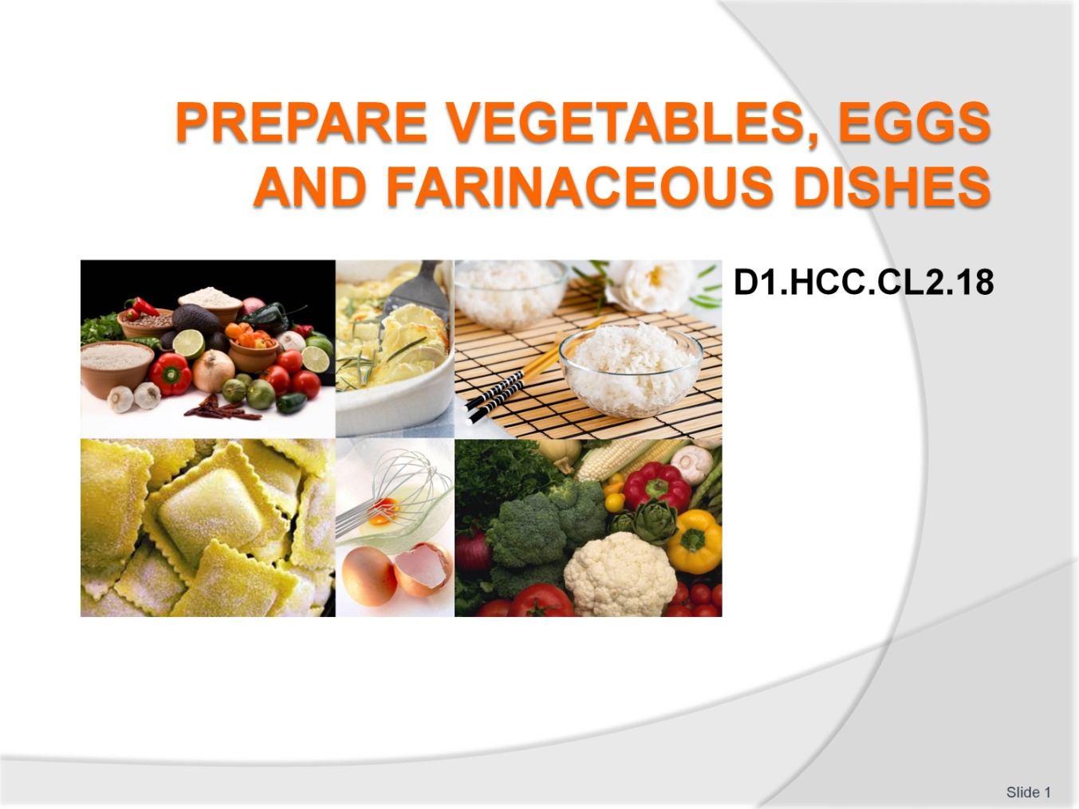
Slide No | Trainer Notes
Welcome students to the class
Discus with students your bone fide to lecture on this subject
Discuss you qualifications in the culinary fields of cooking and teaching background.

Slide
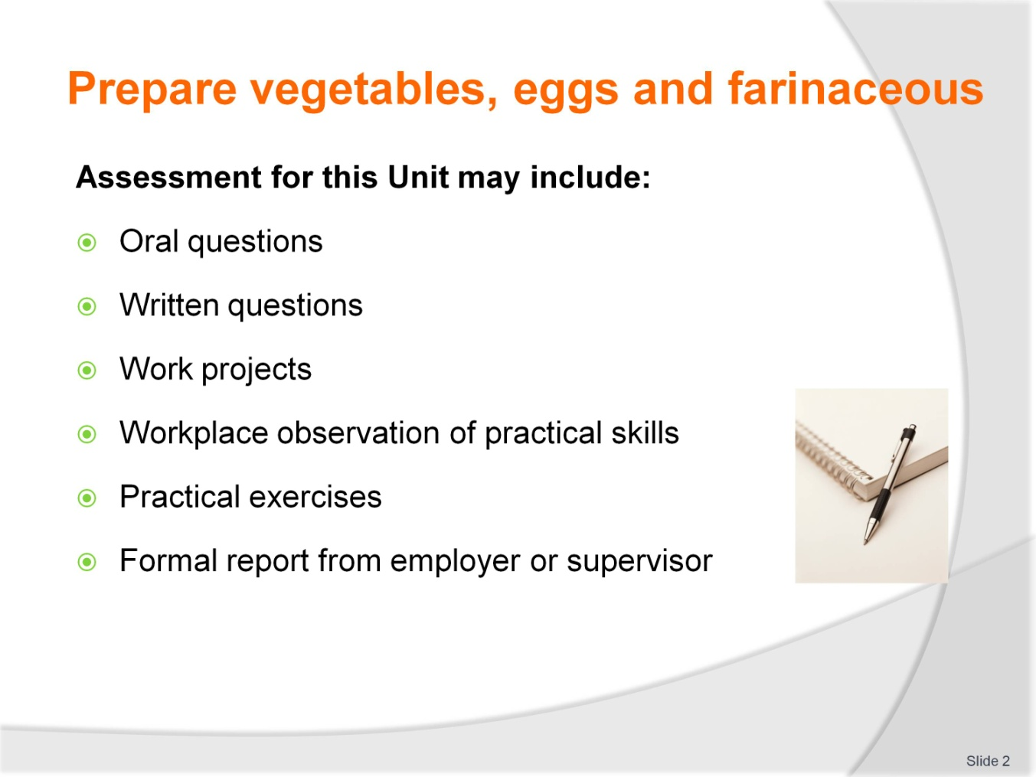
Slide No | Trainer Notes
Trainer to advise
Trainer advises students that assessment for this unit may take several forms all of which are aimed at verifying they have achieved competency for the unit as required
Trainer indicates to students the methods of assessment that will be applied to them for this unit.

Slide
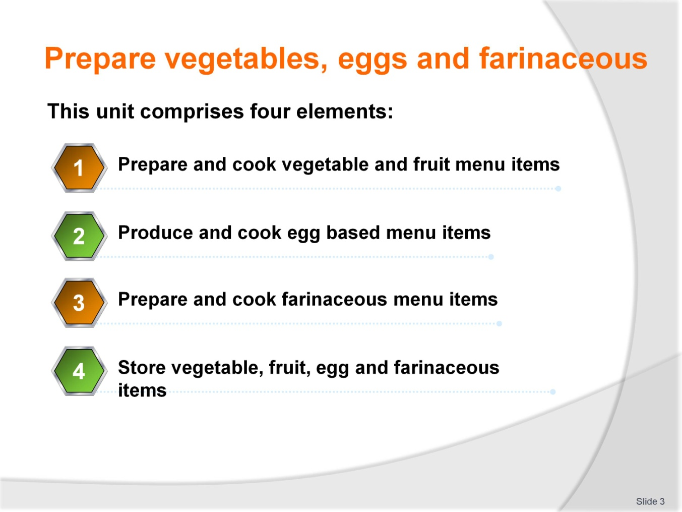
Slide No | Trainer Notes
Trainer to advise
Trainer advises students this unit comprises four elements, as listed on the slide explaining:
Each Element comprises a number of Performance Criteria which will be identified throughout the class and explained in detail
Students can obtain more detail from their Trainee Manual
The course presents advice and information but where their workplace requirements differ to what is presented, the workplace practices and standards must be observed.

Slide
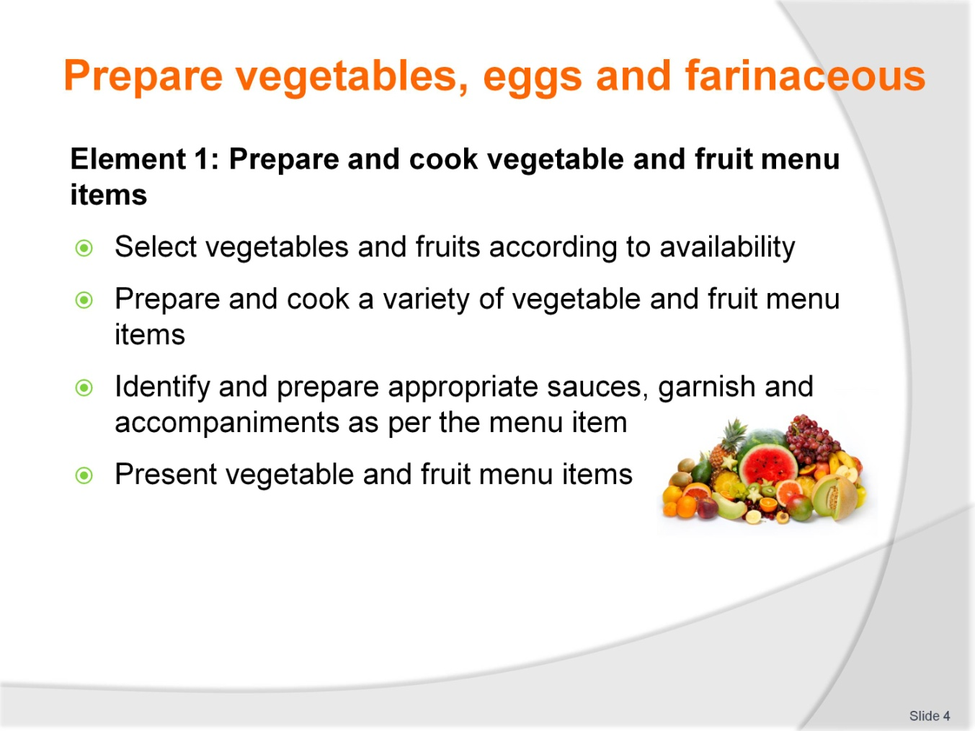
Slide No | Trainer Notes
Trainer to advise
Trainer to relate performance criteria to element 1
Performance criteria is the process by which the students training match the learning element
The element is the skill
To assess competency in the skill; the performance criteria is used to outline activities that can be used to assess competency
The trainer should relate how the performance criteria is related to the element
To be able to prepare vegetable eggs and farinaceous dishes the students must be able to
Prepare and cook vegetable and fruit menu items:
- Select vegetables and fruits according to availability
- Prepare and cook a variety of vegetable and fruit menu items
- Identify and prepare appropriate sauces, garnish and accompaniments as per the menu item
- Present vegetable and fruit menu items.

Slide
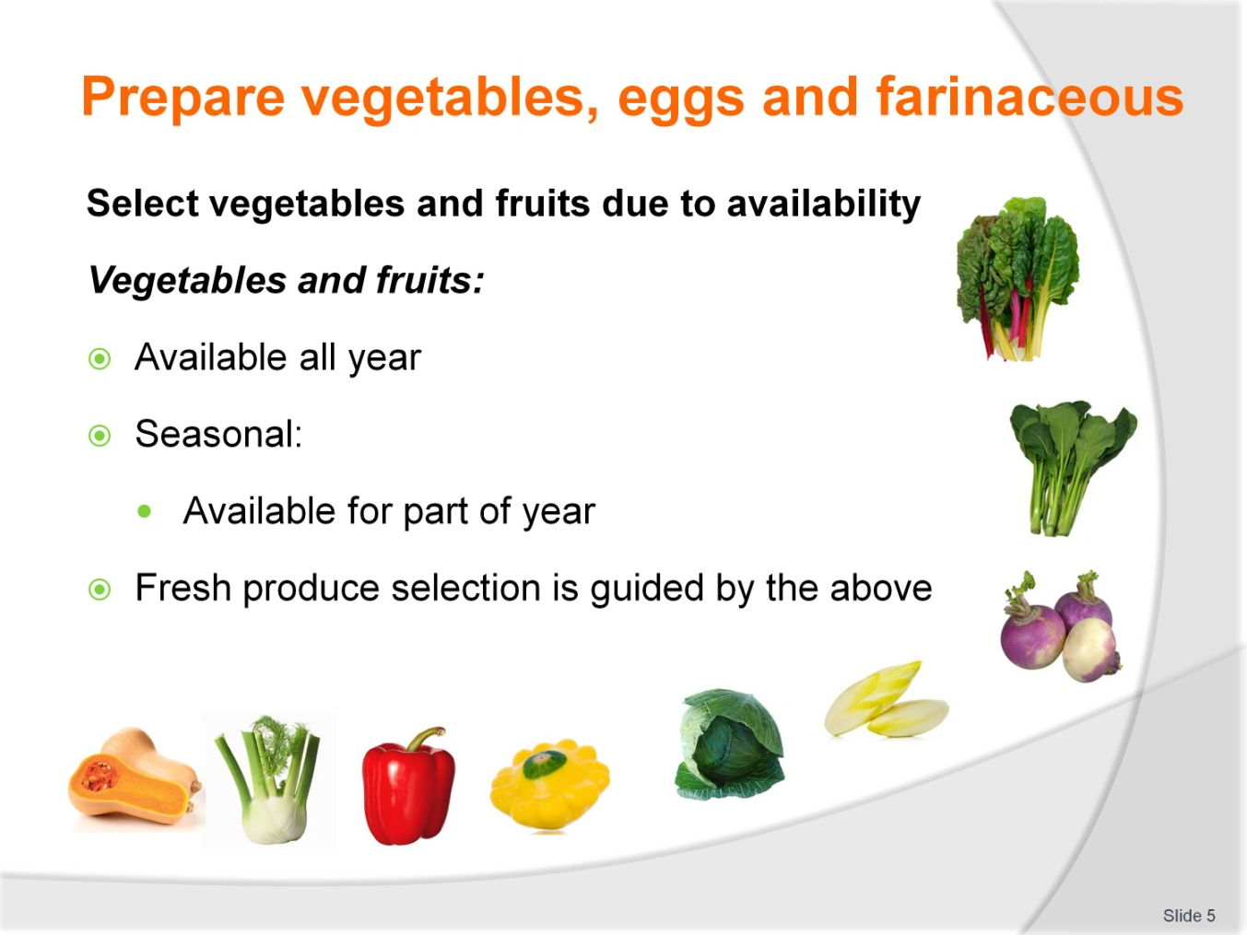
Slide No | Trainer Notes
Trainer to advise
Catering establishments need to be aware of the availability of produce to be able to offer the BEST that the market place has to offer; to their customers
Is the establishment selling to tourist market and supplying western style foods from foreign countries
Supplying local foods in local dishes to both local and foreign customers
Some vegetables are available all year round
Some are seasonal
Some local, some from other parts of the country and the rest will have to be imported by land, air or sea.

Slide
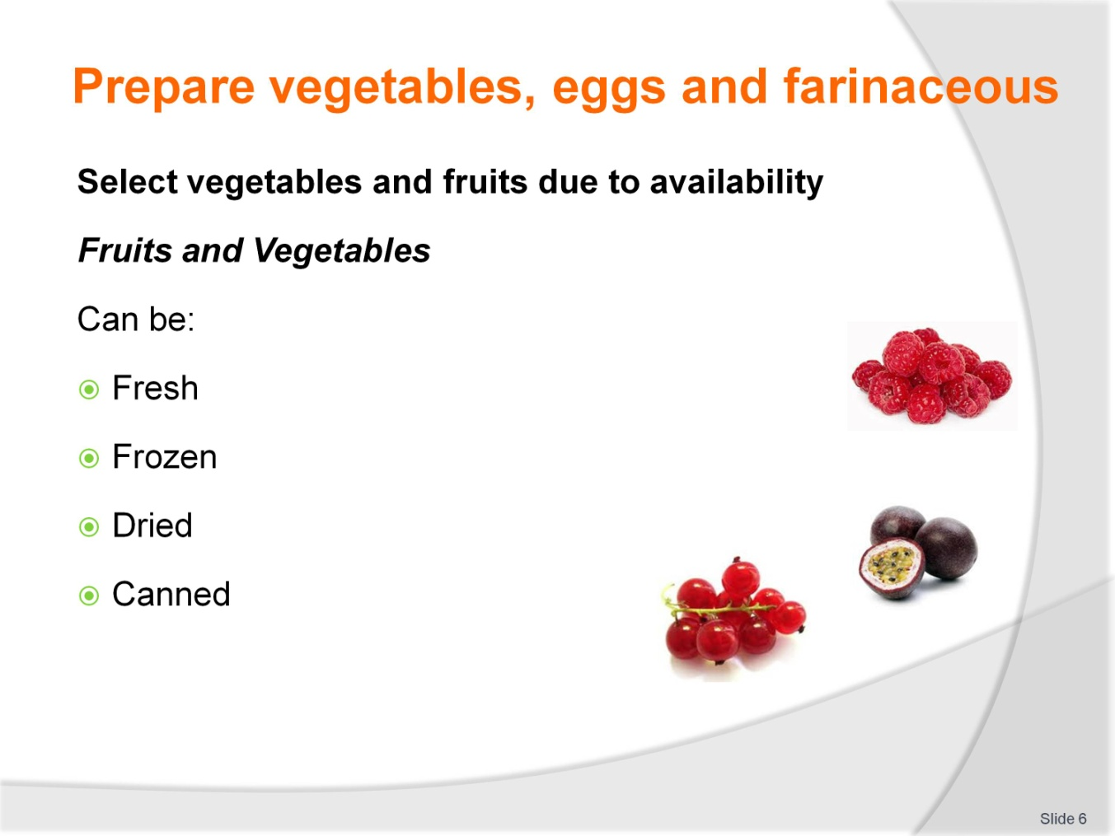
Slide No | Trainer Notes
Trainer to advise
Alternatives can be found from other medium rather than fresh
What does the enterprise wish to use
All fresh
All canned
All frozen
Most establishments will have a mixture
Fresh that is supplemented with frozen followed by canned and dried depending on the dish and the preference of the enterprise management and chef.

Slide
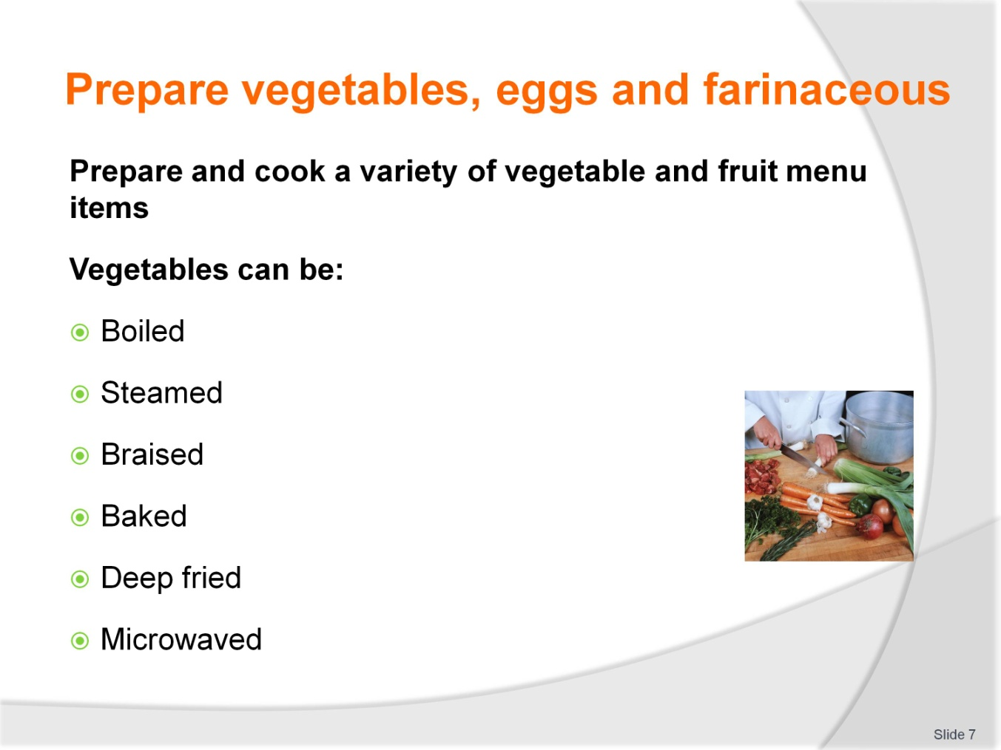
Slide No | Trainer Notes
Trainer to advise
Root vegetables can be boiled roasted or baked
Leafy vegetables are best quickly blanched then served
Other vegetables are best cooked gently in water until texture is at a state that makes them palatable as per recipe requirements.

Slide
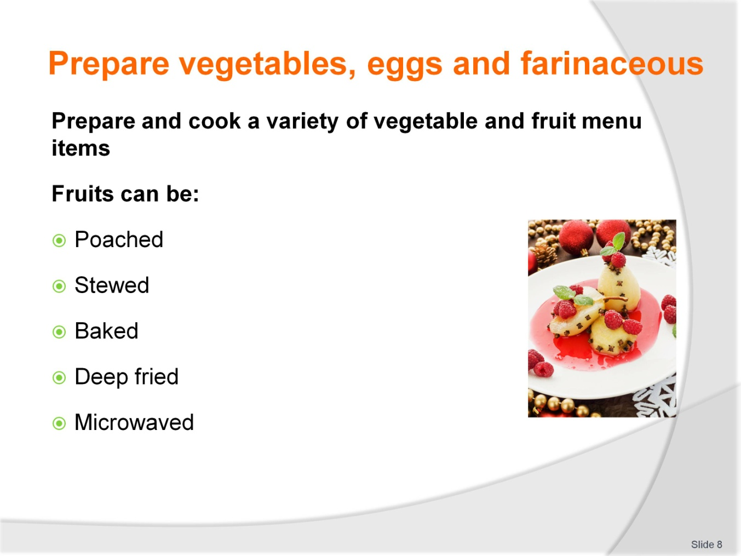
Slide No | Trainer Notes
Trainer to advise
Fruits can be eaten raw or cooked
Many fruits require minimal cooking
Soft fruits are best eaten fresh
Hard fruits like apples and quinces need to be cooked and may require sweetening agent added to improve flavour: sugar
Spices can be used to enhance flavours
Deep frying allows for textural variety in dish with flavour from cooking method and keeping flavour of fruit in original state; Apple fritters with ice cream
Fruits that are baked in pastry have to be cooked before going into the pastry shell
Fruits contain much water and hard structural cell that needs to be softened before
Water leaching out of the fruit will make the party soggy and spoil the product.

Slide
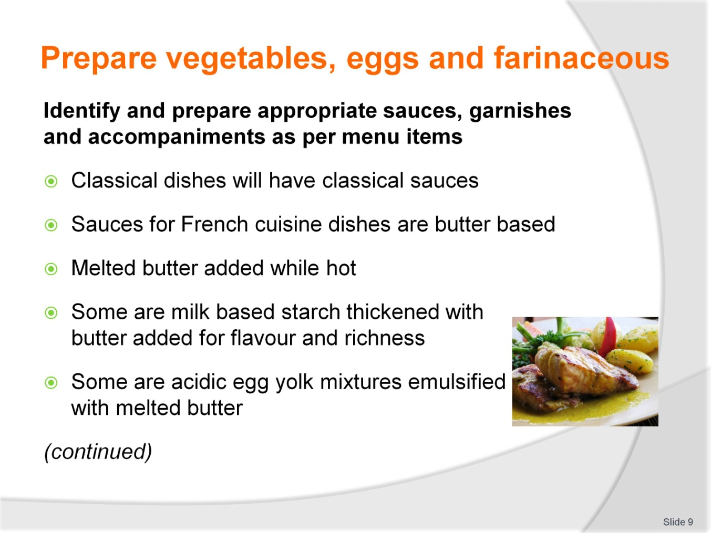
Slide No | Trainer Notes
Trainer to advise
Sauces can be technically complicated or simple
This is defined by the dish that is being prepared.

Slide
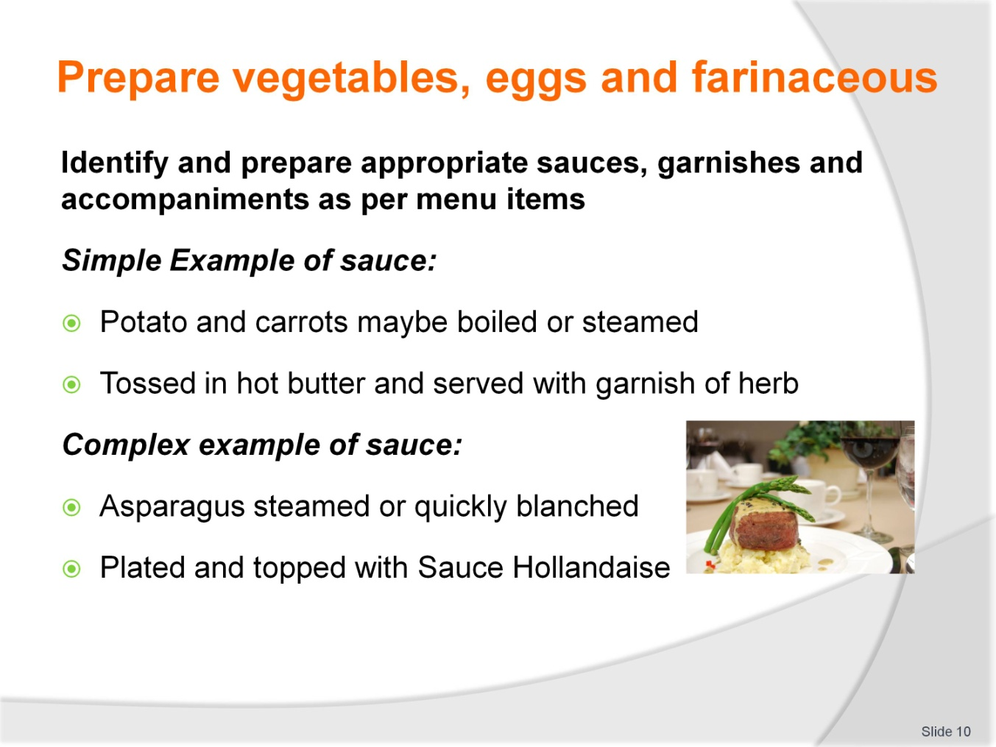
Slide No | Trainer Notes
Trainer to advise
Classical dishes will have classical sauces
Modern dishes will have tasty sauces that are uncomplicated
Sauces can be simple
Garnishes should be simple and easy to prepare.

Slide
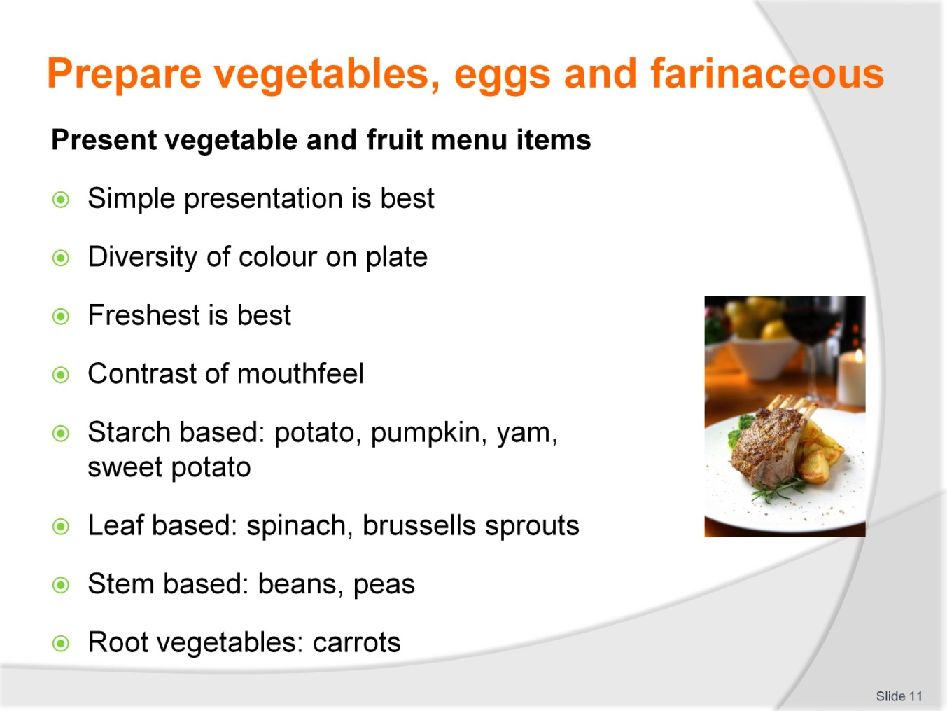
Slide No | Trainer Notes
Trainer to advise
Keep presentations simple
Use colour to best advantage
Keep it simple
Keep it interesting.

Slide
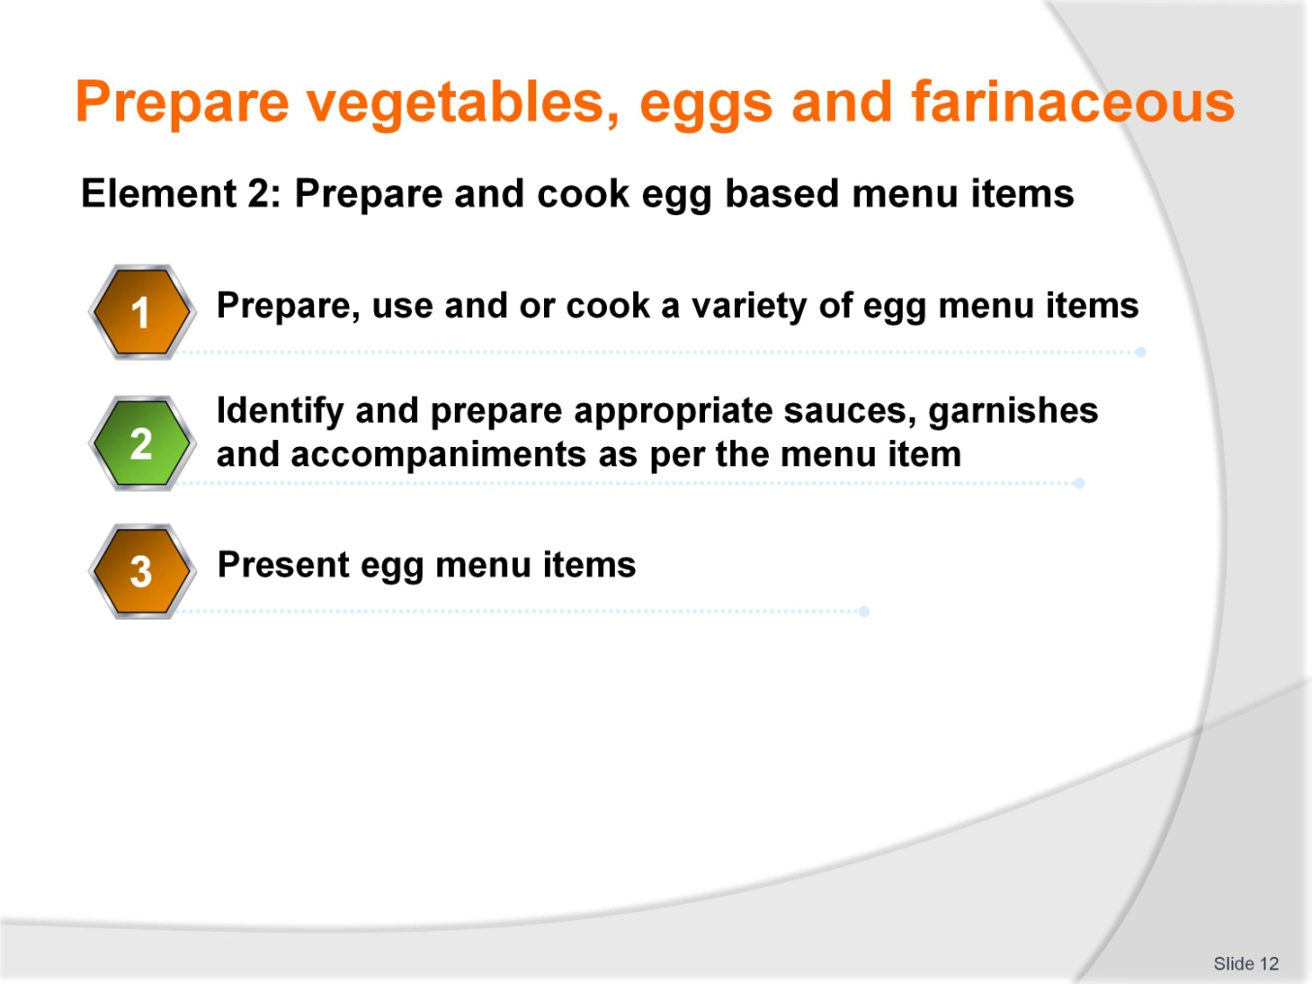
Slide No | Trainer Notes
Trainer to advise
Trainer to relate performance criteria to element 2
Performance criteria is the process by which the students training match the learning element
The element is the skill
To assess competency in the skill; the performance criteria is used to outline activities that can be used to assess competency
The trainer should relate how the performance criteria is related to the element
To be able to Prepare vegetable eggs and farinaceous dishes the students must be able to
Prepare and cook vegetable and fruit menu items:
- Select vegetables and fruits according to availability
- Prepare and cook a variety of vegetable and fruit menu items
- Identify and prepare appropriate sauces, garnish and accompaniments as per the menu item
- Present vegetable and fruit menu items.

Slide
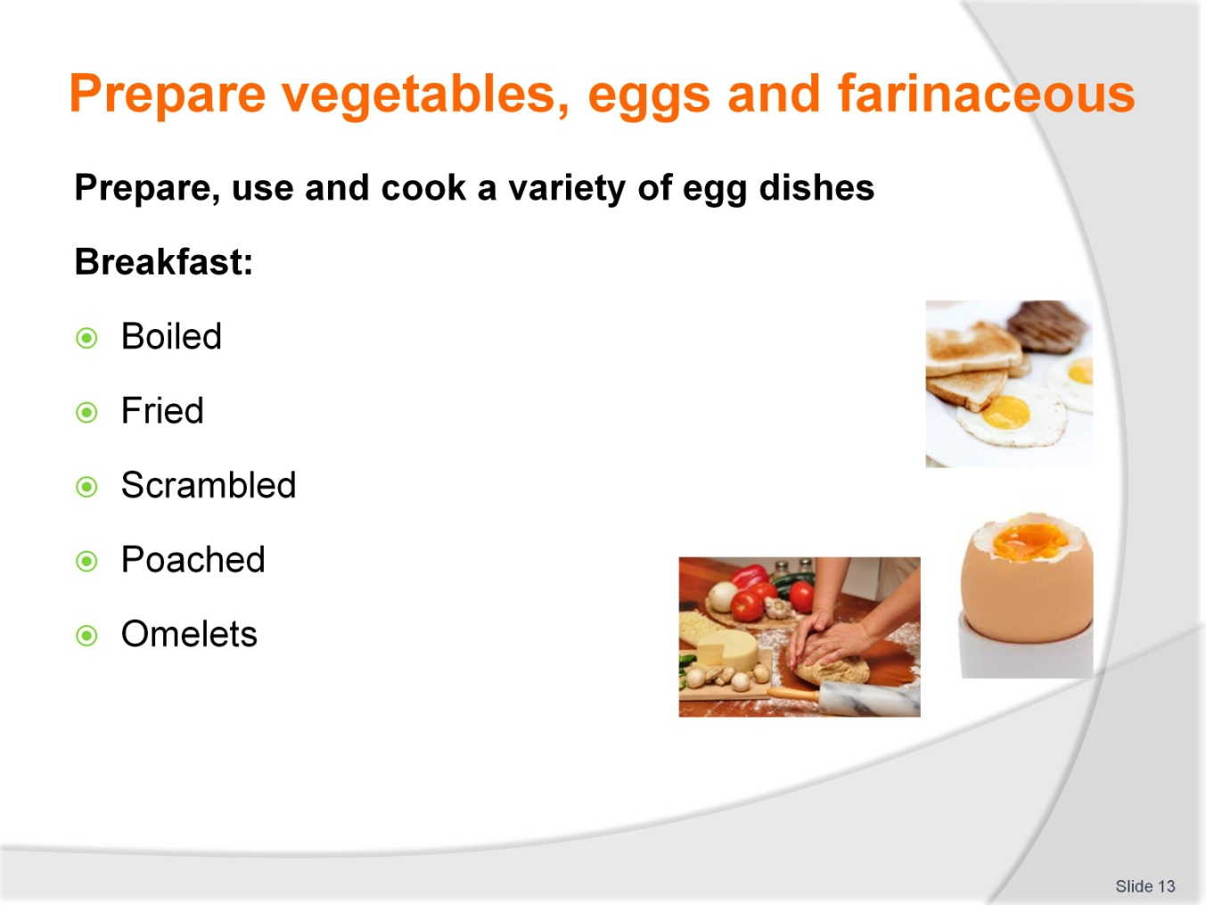
Slide No | Trainer Notes
Trainer to advise
Eggs used are Egg of the chicken. Other eggs can be used but that is up to the individual
Eggs can be conveniently boiled in the shell. But when placed into cold water at room temperature and cooked until boiling
Too much boiling will cause the dark blue sulphur ring to appear at edge of yolk and spoil the look of the cut boiled egg
All other methods of cooking eggs require them to be removed from the shell.
Care must be taken to exclude any broken bits of shell being allowed to remain in egg while it is cooking
Shell in cooked egg can be dangerous if consumed. Larger pieces getting caught un throat of consumer. Smaller gritty pieces leave a uncomfortably feeling in mouth when ground in teeth. These customers will not be back
Fried and poached are popular ways to serve eggs
Poached being the gentlest way to cook eggs
Classic Eggs Benedict with sauce Hollandaise; gently poached eggs 80ºC – 90ºC until egg white has set; should be soft but completely white
Fried eggs are faster form of cooking and go well with bacon. Eggs and bacon on toast; popular in western countries as breakfast food
Scrambled eggs requires all egg to be blended until the white and the yolk cannot be distinguished; cooked gently over low heat until coagulation; this gives a soft mouth feel when eating. Overcooking will result in hard well set protein in mouth
Omelettes have several derivations but classic French is cooked quickly in hot buttered pan and folded either side to have cigar shape and turned onto plate with seal folds underneath. Centre of omelettes should be ‘bavause’; which means soft moist and slightly runny inside; should be moist mouth feel but set.

Slide
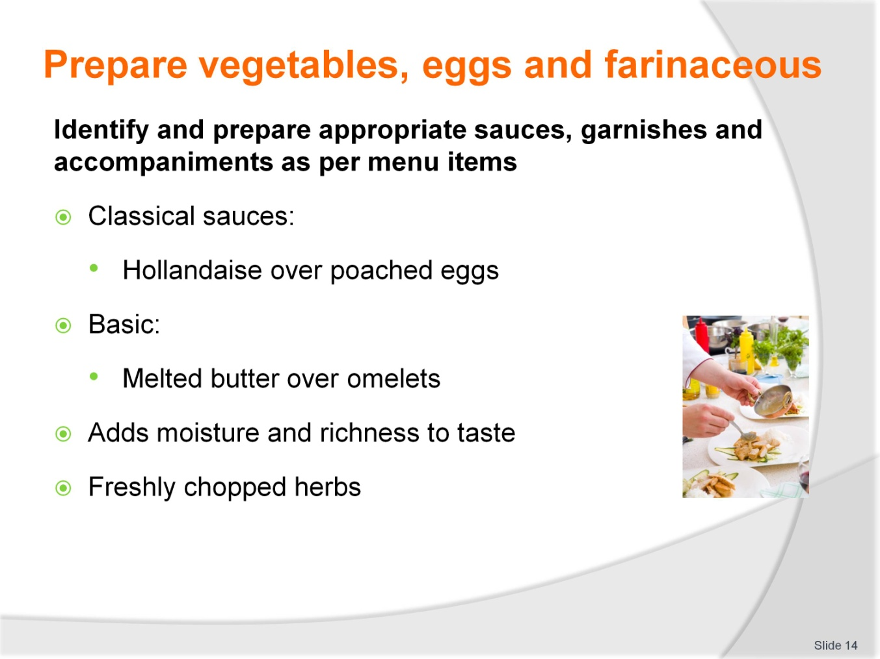
Slide No | Trainer Notes
Trainer to advise
Breakfast eggs should be plain, simple, uncomplicated
The more intricate techniques need to be kept for a time when customers have time to sit and wait for proper technique to be carried out
Eggs for breakfast have to be cooked in minimal time especially in establishments that cater for the working people rushing off to begin the days work
More formal breakfast that are for business people have time on their side so more technique can be used but his extra time taken is more costly
Sauces kept to minimum. Very few breakfast egg dishes have complicated sauces, if any
Garnishes are also kept to minimum; freshly chopped herbs, parsley, is the most common.

Slide
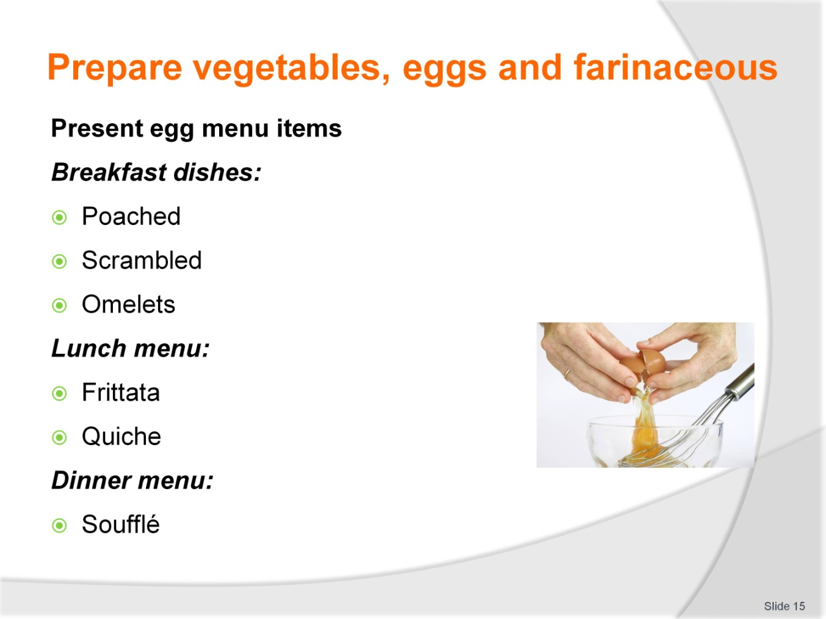
Slide No | Trainer Notes
Trainer to advise
Breakfast dishes are served quickly and simply
Lunch menu is again casual but more complex dishes may be offered; frittata; Spanish omelettes; quiche
Frittata can prepare the day before and served cold with salad
Quiche; French open savoury tart uses eggs in milk and cream to carry fillings.
These can be served hot or cold; cold is popular as it can be consumed with ease. Too higher a fat content can require this to be served warm for more palatable enjoyment
Dinner menu may find eggs in béarnaise sauce with beef steak or in dessert soufflé.

Slide
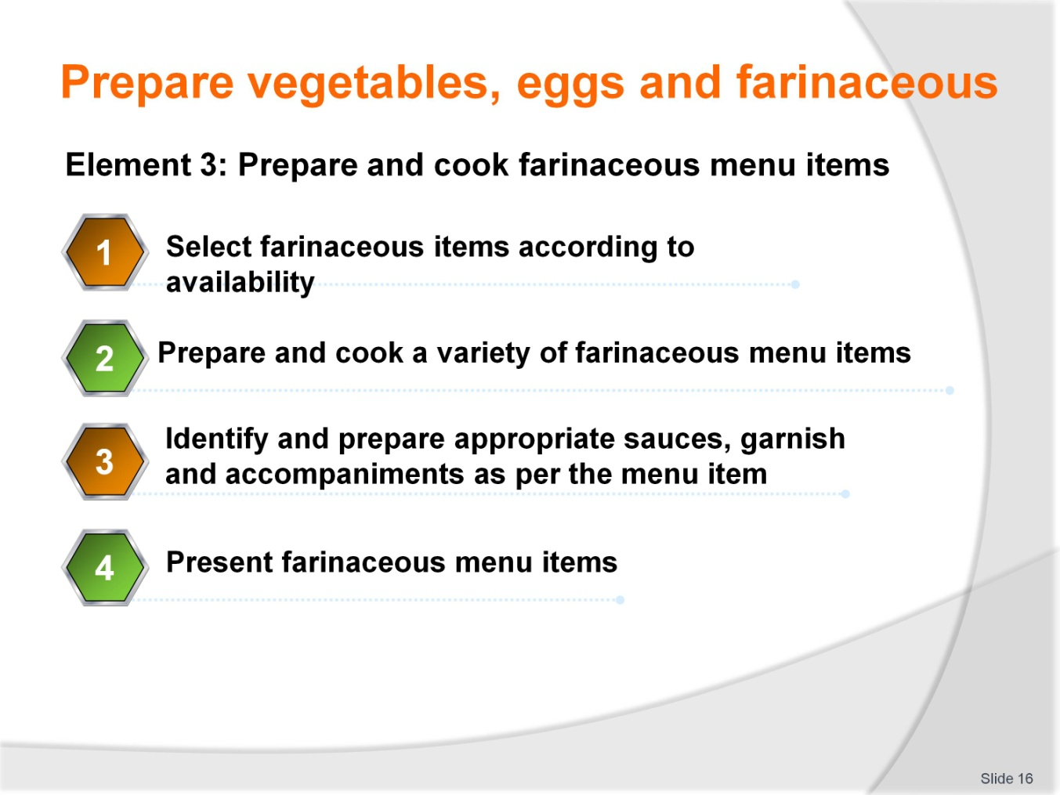
Slide No | Trainer Notes
Trainer to advise
Trainer to relate performance criteria to element 3
Performance criteria is the process by which the students training match the learning element
The element is the skill
To assess competency in the skill; the performance criteria is used to outline activities that can be used to assess competency
The trainer should relate how the performance criteria is related to the element
To be able to Prepare vegetable eggs and farinaceous dishes the students must be able to
Prepare and cook farinaceous menu items:
- Select farinaceous items according to availability
- Prepare and cook a variety of farinaceous menu items
- Identify and prepare appropriate sauces, garnish and accompaniments as per the menu item
- Present farinaceous menu items.

Slide
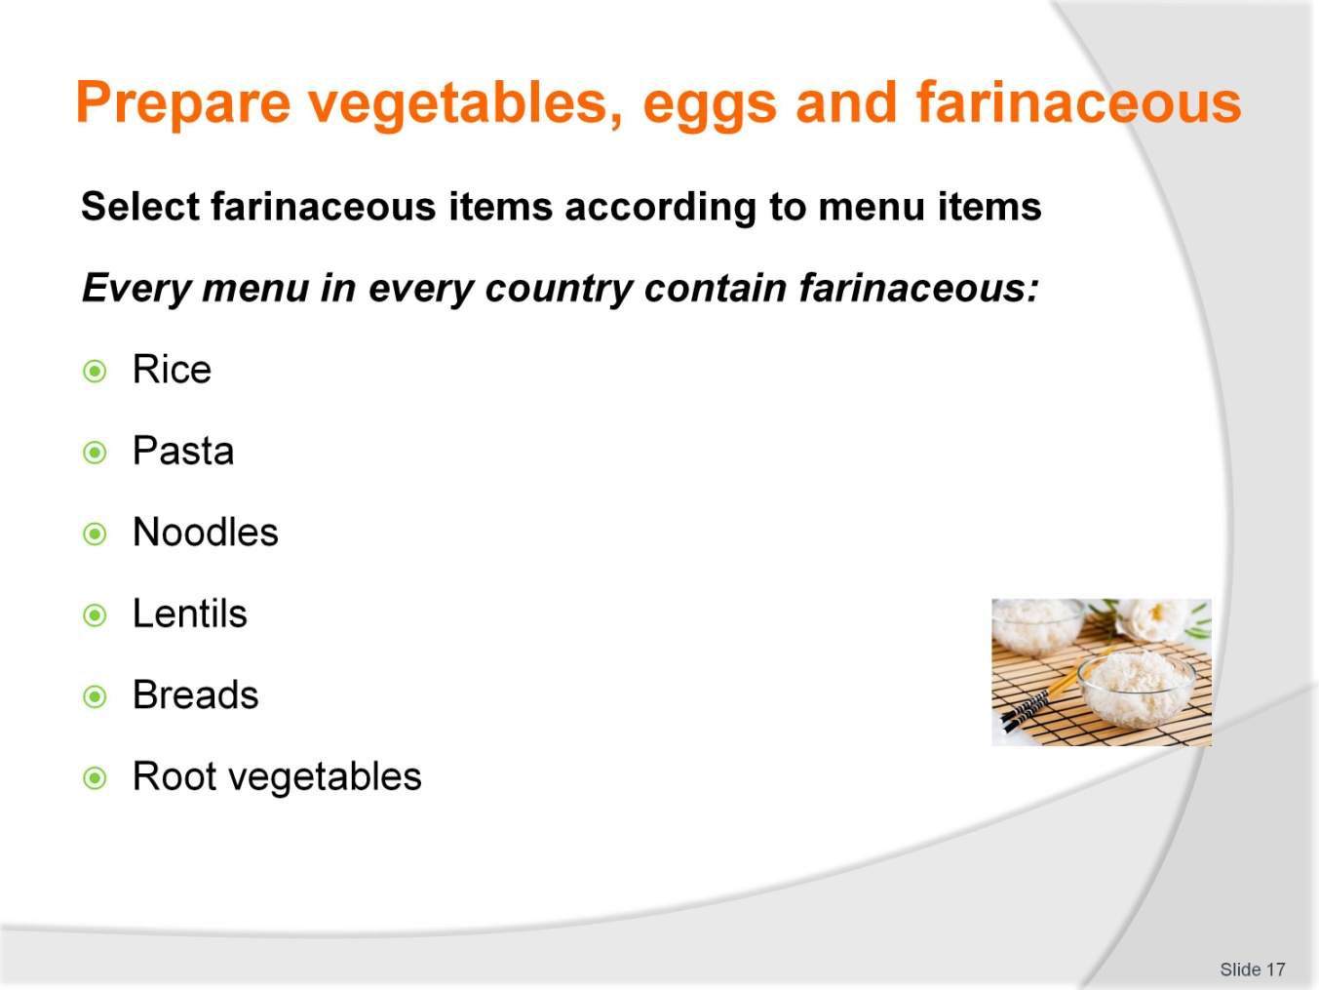
Slide No | Trainer Notes
Trainer to advise
Farinaceous means starch. Every person consumes starch in their meals
The body converts the starch that we consume into sugars and that fuels the body and allows it to function
Starch is in many foods and preparation of these foods give variety to the diet and choice to the consumer
To make the starch edible it must be cooked with or in water
Starch is cooked by applying heat to liquid
As the liquid heats the starch absorbs the moisture and expands fully to become edible for humans
In bread this is already completed in the mixing and baking process so it can be consumed as it is
Products like rice and lentils need to be cooked to make it palatable and edible. Cooked in aromatic liquids make them more appealing and flavoursome to consume
Noodles and pasta are a manufactured product that will have to be cooked before consumption. Like bread if it was unbaked
Pasta and noodles need to be cooked in water until they have reached the stage of doneness required by the dishes cuisine. Some are firm to the tooth and some are well cooked until they are soft to the tooth
Root vegetables like potato, pumpkin and yams are also cooked to the cuisine requirements but these can be dry cooked due to the high liquid content already in the vegetable. Dry cooking is roasting or baking.

Slide
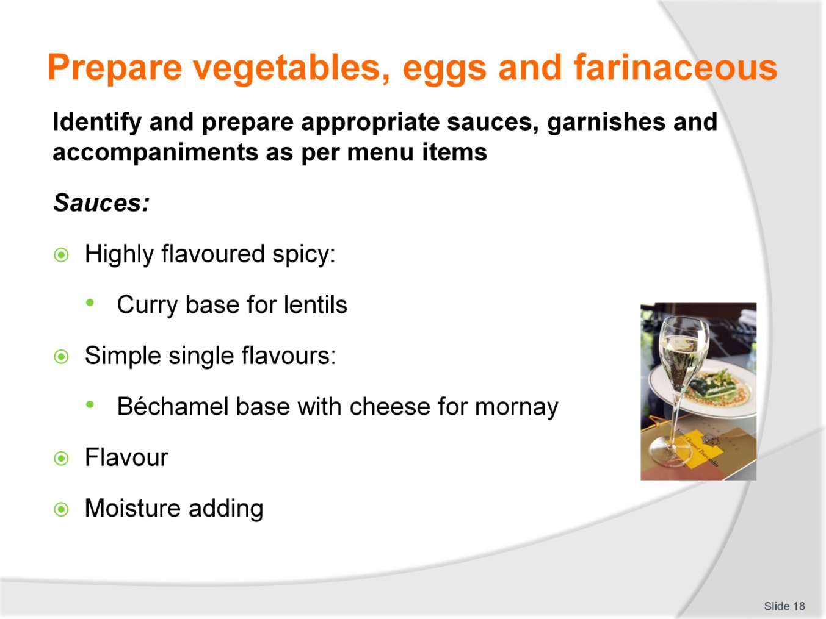
Slide No | Trainer Notes
Trainer to advise
Starchy farinaceous products can be dry to eat on their own. Draws the moisture from the mouth as they are eaten so they are best served with a sauce to add moisture and make consumption more enjoyable
Lentils tend to be cooked in spicy or flavoursome liquids that have spices and some other aromatics like onion garlic and herbs added
Flavour bases can be manufactured and added to water that lentils will be cooked in until they are deemed cooked. Some are cooked firm while some lentils fall apart quickly to thicken the water. These are then served as a side accompaniment to main protein or as main meal for non meat eating societies
Béchamel is a savoury white sauce, milk thickened with starch and enriched with addition of butter. This is further flavoured with cheese to enhance desirability and sometimes a spice like nutmeg
This sauce is used in many western vegetable dishes. It can be poured over roasted root vegetables and glazed in hot under hot grill to gratin the top surface
Classic noodles dish is: Macaroni and cheese. A staple for working class people that needed to fill up growing children and hard working men on a low money budget
Sometimes served as a side accompaniment for diets that do not have potatoes and main sauce of starch
All sauces need to be flavoursome and do add moisture to enhance the mouth feel of what people are consuming
Garnishes can be chopped herbs.
Slide
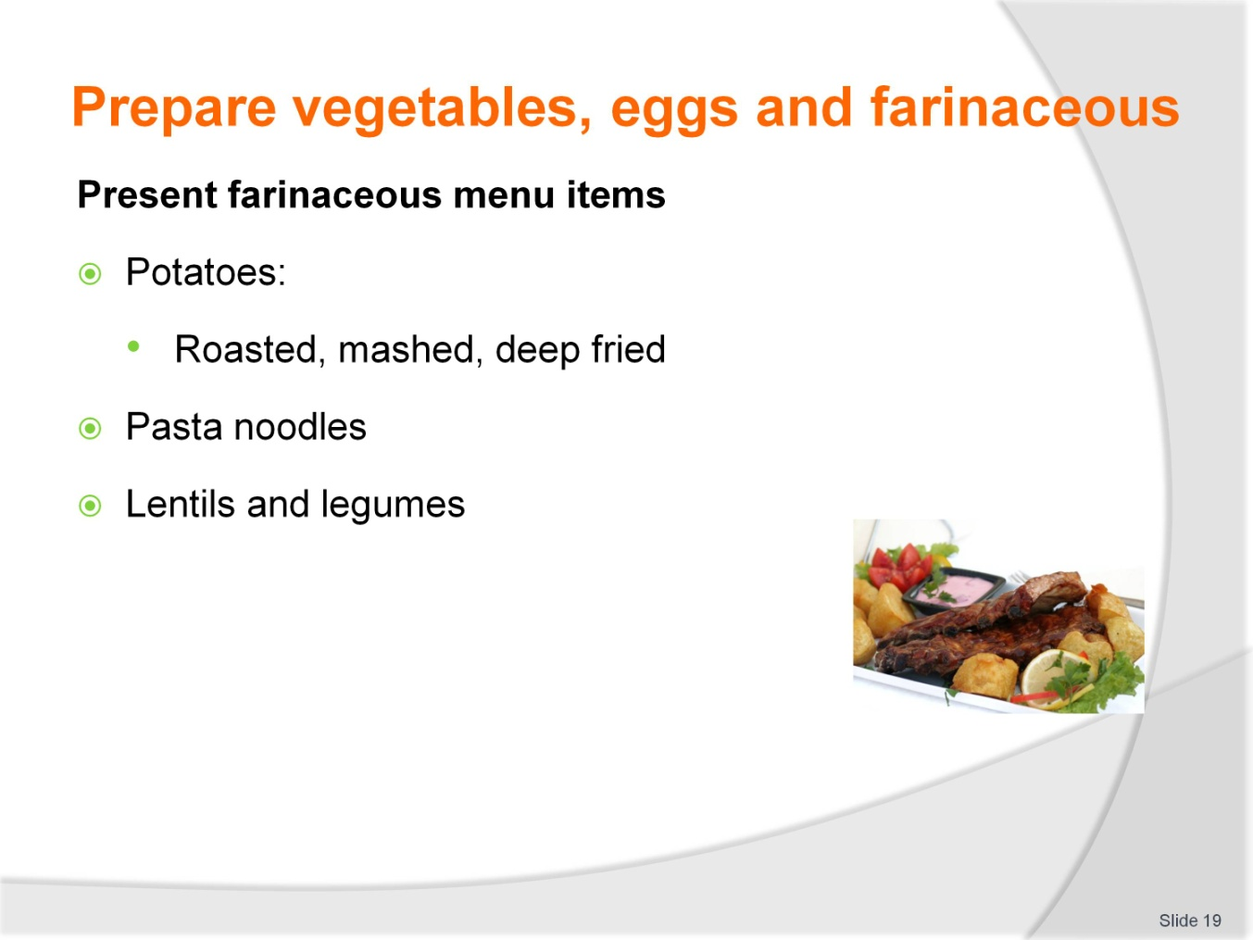
Slide No | Trainer Notes
Trainer to advise
Farinaceous elements or menu items can be individual serving or accompaniments to main protein menu item
All will need to be presented or served with a sauce; the sauce will be the main flavour for the farinaceous item
Farinaceous menu items do not necessarily have much flavour, that some from sauces with which they are served
Root vegetables like potato need added moisture to enrich the flavour.
Ask Students
They eating noodles without sauce ……… flavour is bland
Try eating rice without sauce ……… bland
Lentils and chickpeas may have interesting textures but flavour is mild.

Slide
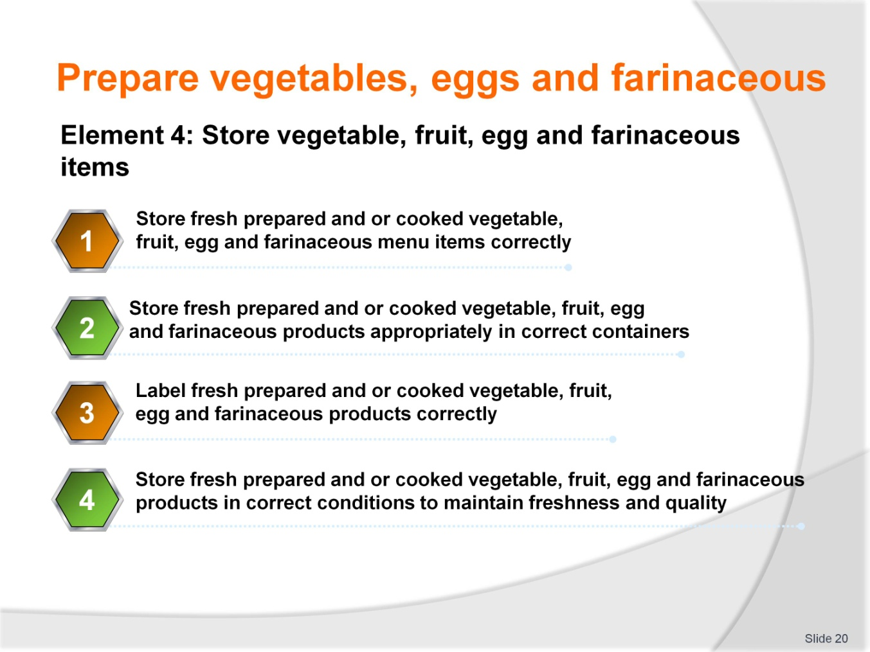
Slide No | Trainer Notes
Trainer to advise
Trainer to relate performance criteria to element 4
Performance criteria is the process by which the students training match the learning element
The element is the skill
To assess competency in the skill; the performance criteria is used to outline activities that can be used to assess competency
The trainer should relate how the performance criteria is related to the element
To be able to Prepare vegetable eggs and farinaceous dishes the students must be able to
Store vegetable, fruit, egg and farinaceous items:
- Store fresh prepared and/or cooked vegetable, fruit, egg and farinaceous menu items correctly
- Store fresh prepared and/or cooked vegetable, fruit, egg and farinaceous products appropriately in correct containers
- Label fresh prepared and/or cooked vegetable, fruit, egg and farinaceous products correctly
- Store fresh prepared and/or cooked vegetable, fruit, egg and farinaceous products in correct conditions to maintain freshness and quality.

Slide
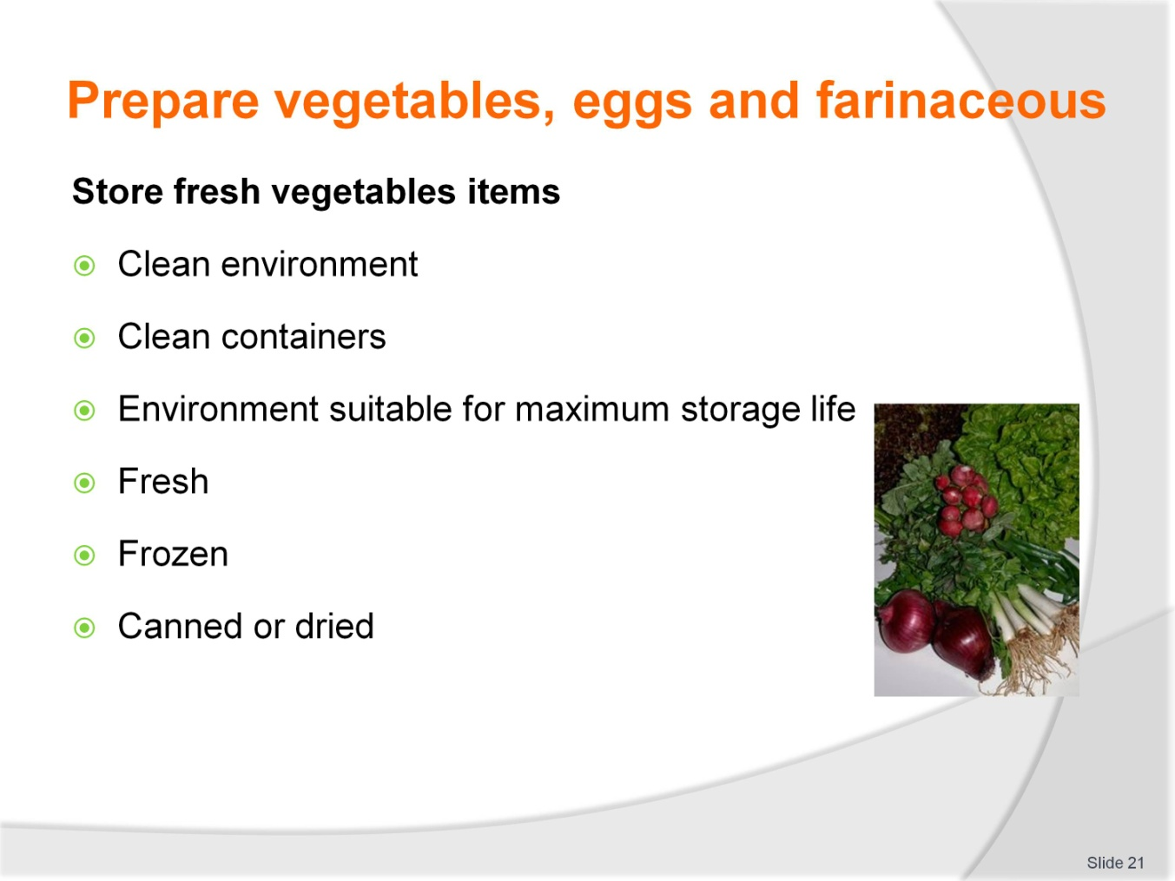
Slide No | Trainer Notes
Trainer to advise
All fresh vegetables are perishable in a very short time
Root vegetables alike potato, yams and pumpkin need to be stored in a cool environment that needs to be well ventilated. Not refrigerated
Fresh leafy vegetables need to be kept chilled to prolong their life; 3-4 days
Store at less than 5ºC, keep covered with plastic to stop from drying the leafy vegetables and help retain moisture
Some vegetables can be stored can be stored well between 7 and 15ºC
Best is to store for minimum period by purchasing on a daily basis what is required for the days trading
Canned vegetables need to be stored in environment that will not be detrimental to safe can storage; cool well ventilated dry environment
Frozen vegetables need constant -18ºC storage for consistency, when thawed they must be used immediately
Frozen potato (French fries) are placed into deep fryer while still frozen so must be kept that way.

Slide
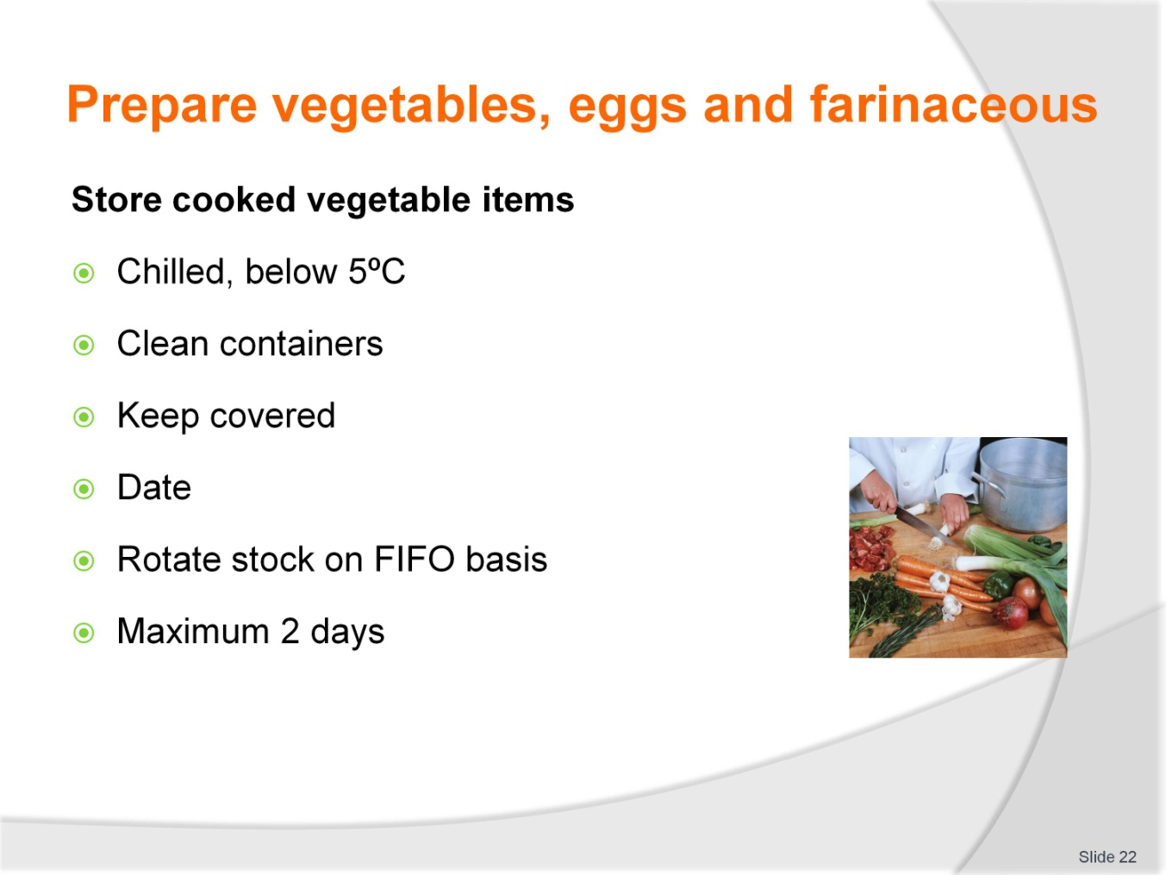
Slide No | Trainer Notes
Trainer to advise
Any cooked vegetables needs to be chilled if they are going to be stored
Storage must be at less than 5ºC for no more than 2 days
Containers must be clean and in good conditions
Stored vegetables must be labelled correctly
Keep stock rotation up to date.

Slide
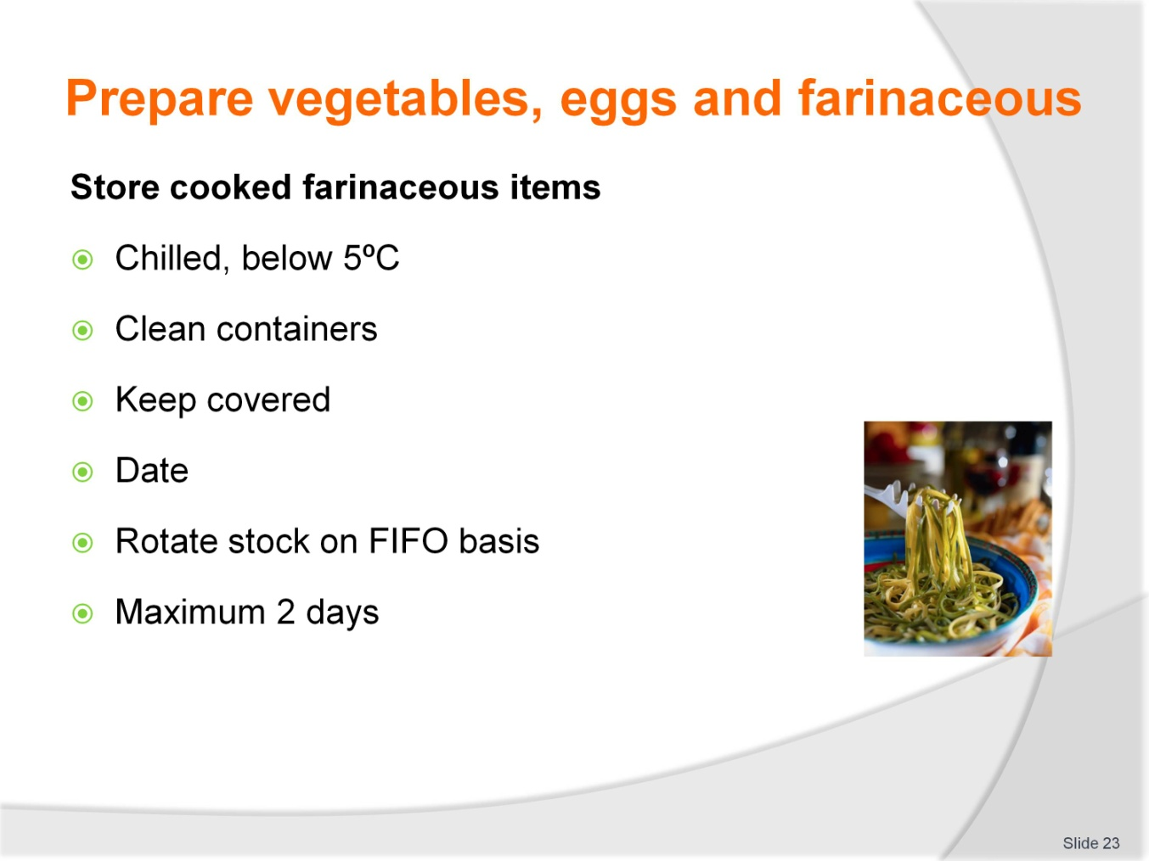
Slide No | Trainer Notes
Trainer to advise
Any cooked farinaceous products need to be chilled if they are going to be stored
Storage must be at less than 5ºC for no more than 2 days
Containers must be clean and in good conditions
Stored product must be labelled correctly
Keep stock rotation up to date.

Slide
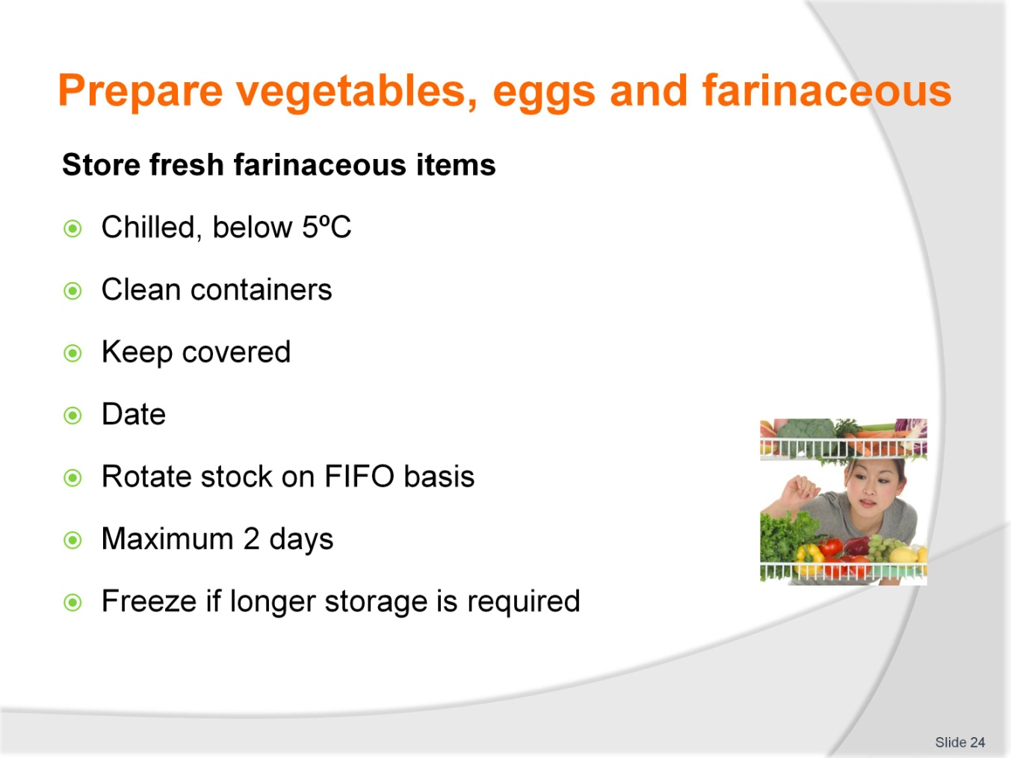
Slide No | Trainer Notes
Trainer to advise
Any fresh farinaceous products need to be chilled if they are going to be stored before cooking
Storage must be at less than 5ºC for no more than 2 days
Longer exposure may result in oxidation in flour resulting in grey flecks appearing in uncooked flour based product
Containers must be clean and in good conditions
Stored product must be labelled correctly
Keep stock rotation up to date.

Slide
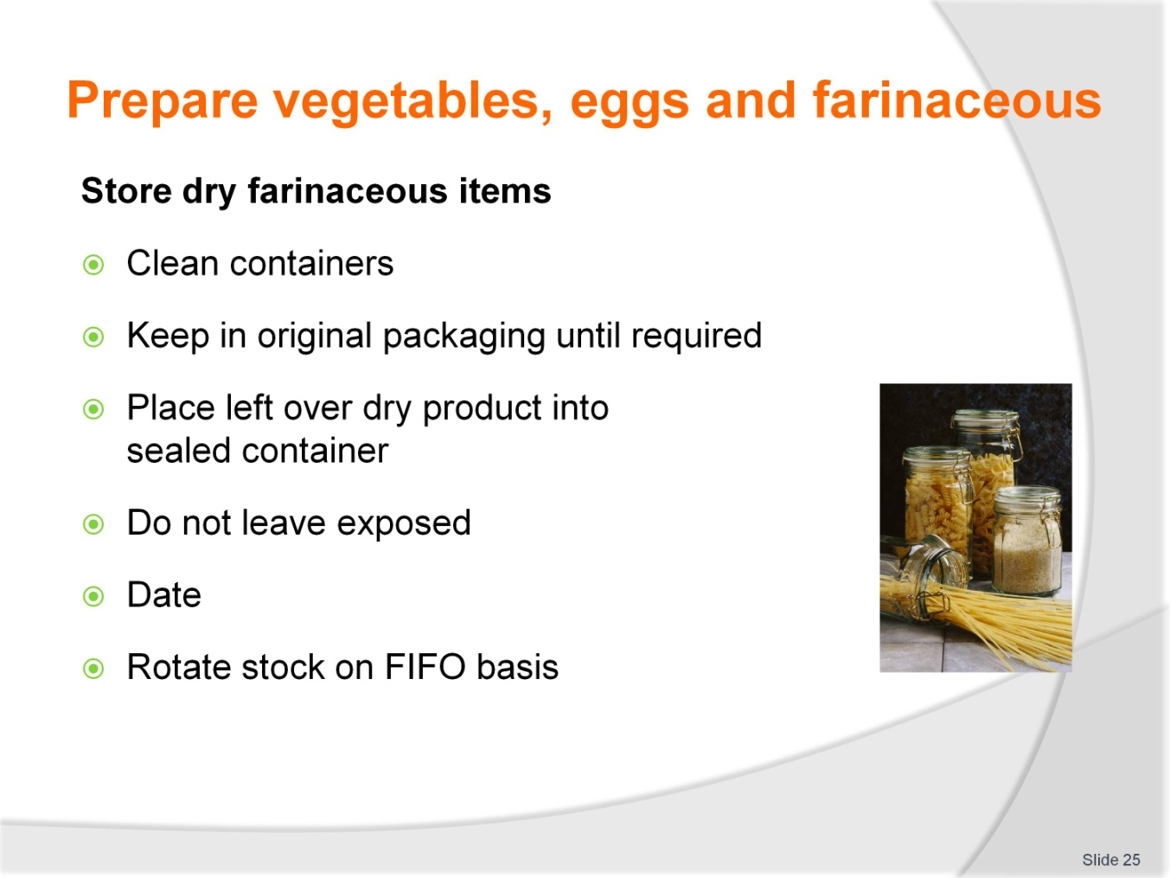
Slide No | Trainer Notes
Trainer to advise
Dry product can be kept stored for long periods of time
Precautions with moisture must be undertaken
Any dry product that get water damaged must be discarded due to risk of mould growth
Keep stored off floors
If packaging is damaged product needs to be de-cantered into secure container to prevent infestation with pests.

Slide
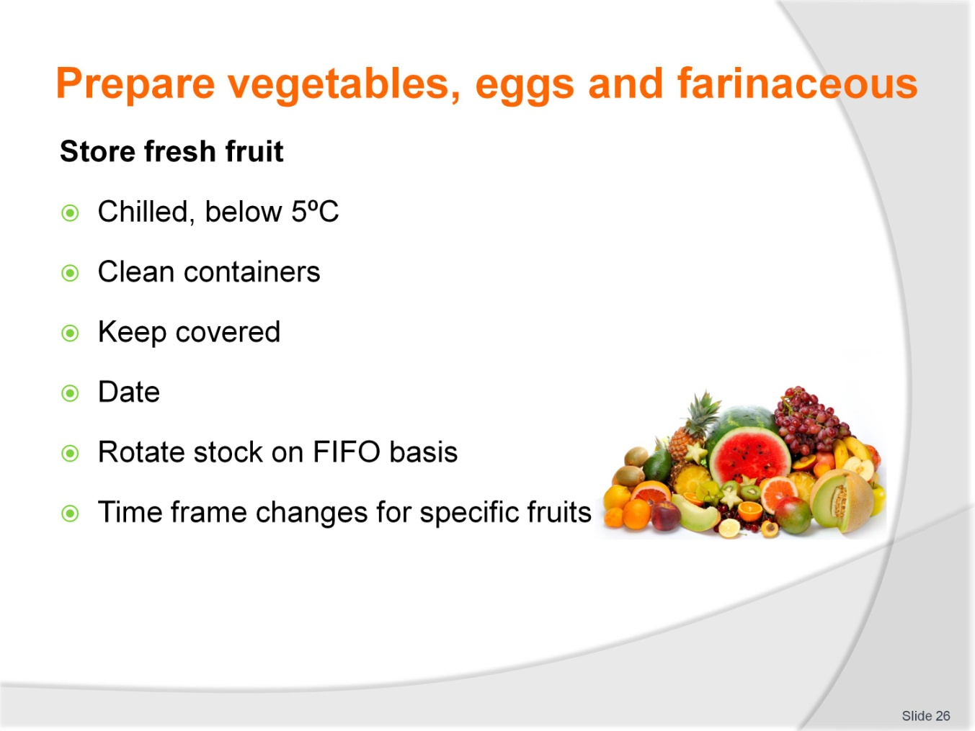
Slide No | Trainer Notes
Trainer to advise
All fruits need to be stored in secure areas
Bananas may be stored in at room temperature as can other fruits
Fresh berries will have a short life if not chilled and mould will grow rapidly
Dried fruits will keep well if moisture is kept away, so packaging must be secure.

Slide
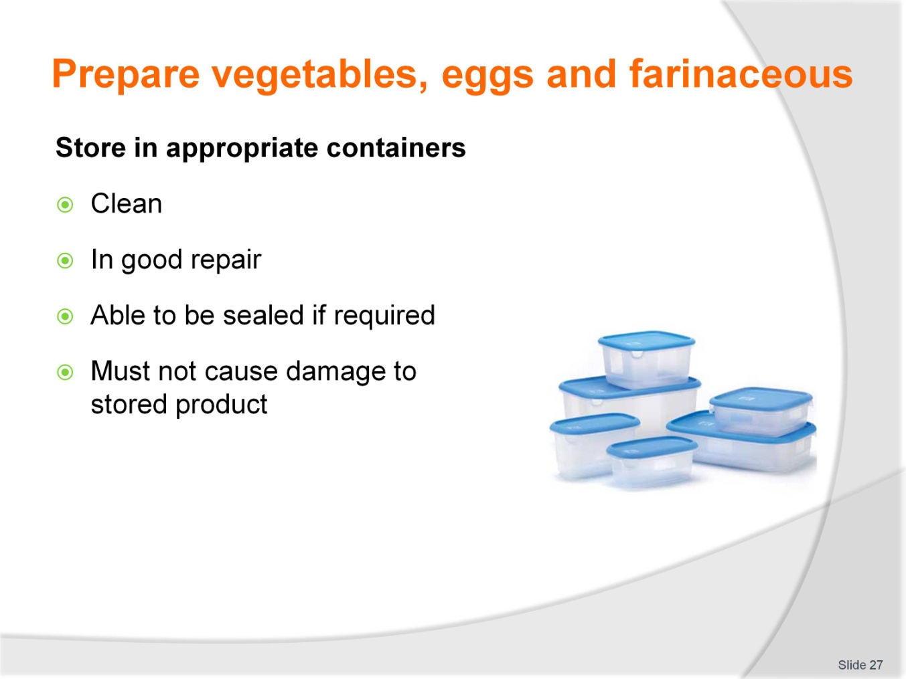
Slide No | Trainer Notes
Trainer to advise
Product is stored for one reason
To be used at a later date
If placed into containers that are not clean to begin then the product may as well have been thrown in rubbish and not stored
Containers must be clean and in a good state of repair so pests are not able to enter and moisture cannot enter
Containers must be able to be closed and sealed if required
Closing the containers must not damage the product being stored.

Slide
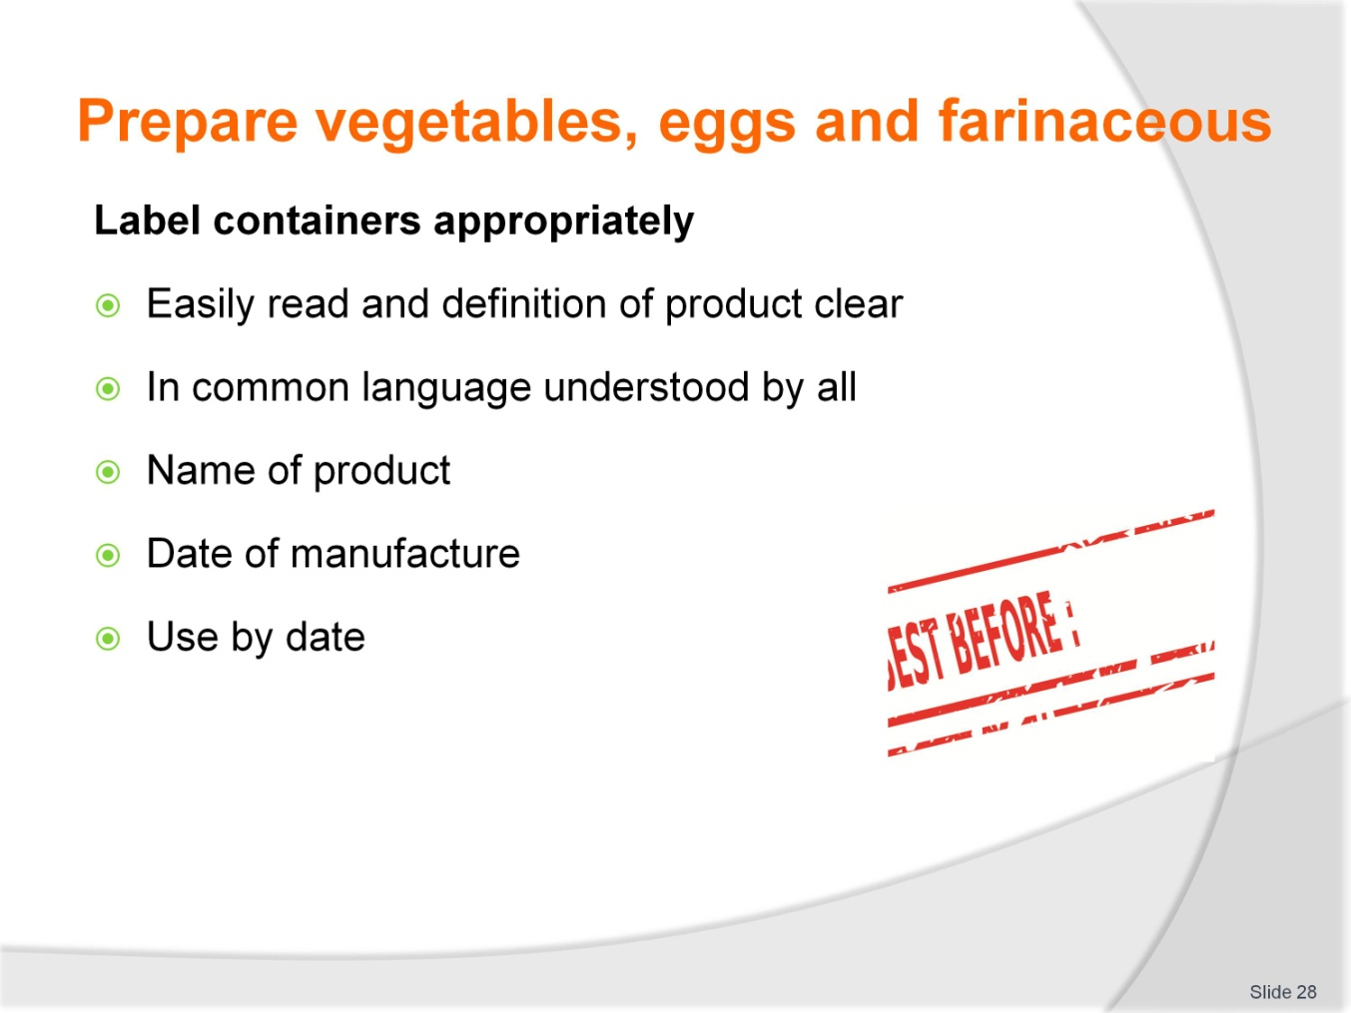
Slide No | Trainer Notes
Trainer to advise
Labelling needs to be clear and defined
Must be legible
Must include:
- Name of product
- Date of manufacture
- Use by date
- Person who packed or labelled product
- Name of manufacturer.

Cookery practical classes: Recommended training equipment
The equipment and kitchen consumables required for the delivery of practical cookery training classes are listed below, in the following categories:
A Items of equipment which should be available for trainer and student use in the training kitchen.
B The cleaning equipment and cleaning products which should be available in a cleaning room located adjacent to the kitchen, so that students can clean down to leave the kitchen in “as found” condition at the end of each class or session.
C Consumables other than foodstuffs which need to kept in the kitchen and available for everyday use in each class or session.
D The items required by each student which would make up their own individual use kit of tools and small equipment.
A: Equipment in the training kitchen:
Commercial cooking stove 4 burner minimum  Stainless steel workbench  Stainless steel sinks  Dishwasher  Refrigeration  Freezers  Cooking pots, multiple sizes  Lids for pots  Frypan  Woks  Chinois of various sizes  Measuring jugs  Mouilis | Food processors  Ramekins  Sieves for dry ingredients  Deep fryers  Steamers  Weighing scales  Baking trays  Roasting dishes  Chopping boards for preparation  Gas fire lighters, cigarette lighters not recommended  Tongs for handling foods  Spiders for handling deep fried foods
B: Cleaning equipment and consumables:
Detergent  Scrubbing brushes  Scourers  Sink plugs  Brooms  Shovel and small brooms | Floor mops  Mop buckets  Wet and dry vacuums  Detergent  Hand dishwashing detergent  Paper hand towel
C: Consumables (non-food) to be available in the kitchen:
Silicon baking paper  Plain white butchers paper  Greaseproof paper  Aluminium foil | Plastic wrap, clear  Plastic sheeting clear  Product boxes of various required sizes  Doyleys as required
D: Student equipment kit should include:
Chefs knife 21 cm  Boning knife 15cm  Paring knives 9cm  Sharpening stone  Honing steel 30cm  Pallet knives  Wooden spoons 3  Whisk 30cm 1  Vegetable peeler  Pastry brush | Piping bags  Piping tubes, various sizes  Spatula, flexible  Tongs  Digital thermometer  Tea towels 6  Cutlery set  Scissors  Fine strainer  Carry case for equipment

Instructions for Trainers for using
PowerPoint – Presenter View
Connect your laptop or computer to your projector equipment as per manufacturers’ instructions.
In PowerPoint, on the Slide Show menu, click Set Up Show.
Under Multiple monitors, select the Show Presenter View check box.
In the Display slide show on list, click the monitor you want the slide show presentation to appear on.
Source: http://office.microsoft.com
Note:
In Presenter View:
You see your notes and have full control of the presentation
Your trainees only see the slide projected on to the screen
More Information
You can obtain more information on how to use PowerPoint from the Microsoft Online Help Centre, available at: http://office.microsoft.com/training/training.aspx?AssetID=RC011298761033
Note Regarding Currency of URLs
Please note that where references have been made to URLs in these training resources trainers will need to verify that the resource or document referred to is still current on the internet. Trainers should endeavour, where possible, to source similar alternative examples of material where it is found that either the website or the document in question is no longer available online.

Appendix – ASEAN acronyms
AADCP | ASEAN – Australia Development Cooperation Program.
ACCSTP | ASEAN Common Competency Standards for Tourism Professionals.
AEC | ASEAN Economic Community.
AMS | ASEAN Member States.
ASEAN | Association of Southeast Asian Nations.
ASEC | ASEAN Secretariat.
ATM | ASEAN Tourism Ministers.
ATPMC | ASEAN Tourism Professionals Monitoring Committee.
ATPRS | ASEAN Tourism Professional Registration System.
ATFTMD | ASEAN Task Force on Tourism Manpower Development.
CATC | Common ASEAN Tourism Curriculum.
MRA | Mutual Recognition Arrangement.
MTCO | Mekong Tourism Coordinating office.
NTO | National Tourism Organisation.
NTPB | National Tourism Professional Board.
RQFSRS | Regional Qualifications Framework and Skills Recognition System.
TPCB | Tourism Professional Certification Board.







